**Experiment / Assignment / Tutorial No. 1**

**Grade: AA / AB / BB / BC / CC / CD /DD**

**Signature of the Staff In-charge with date**

|  |
| --- |
| **Batch: A3 Roll No.: 16010121045 Experiment / assignment / tutorial No.: 1** |

|  |
| --- |
| **Title:** Basic Gates & Universal Gates |

**_____________________________________________________________________________________**

**Objective:** To study the basic gates: AND, OR, NOT and universal gates: NAND, NOR, XOR, XNOR

**_____________________________________________________________________________**

**Expected Outcome of Experiment:**

**CO1:** Recall basic gates and binary, octal & hexadecimal calculations and conversions.

**_____________________________________________________________________________**

**Books/ Journals/ Websites referred:**

* Vlab Link: [http://vlabs.iitkgp.ernet.in/dec/#](http://vlabs.iitkgp.ernet.in/dec/)
* R. P. Jain, “Modern Digital Electronics”, Tata McGraw Hill
* http://www.ee.surrey.ac.uk/Projects/Labview/gatesfunc/
* http://www.electronics-tutorials.ws/boolean/bool_6.html

**Pre Lab/ Prior Concepts:**

Gate is a logic circuit with one or more inputs but only one output. Gates are digital (two state) circuit because the input & output are either low or high. Gates provide high output for certain combinations of input & for other combinations the output is low. Total number of combinations for a gate is 2^n; where n is number of input.

**Classification:** The two types of gate are:

1. **Basic or Fundamental Gates:**
2. **Derived Gates:**

**Symbols of gates**

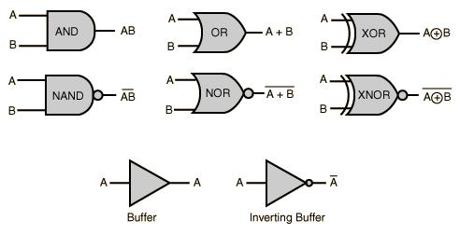

|  |  |
| --- | --- |
| **TYPE OF IC** | **SPECIFICATION** |
| IC 7408 | AND: Quad 2 input AND TTL IC HEX |
| IC 7432 | OR: Quad 2 input OR gate TTL IC |
| IC 7404 | NOT: Inverter TTL IC |
| IC 7402 | NOR: Quad 2 input NOR gate TTL IC |
| IC 7400 | NAND: Quad 2 input NAND gate TTL IC |
| IC 7486 | EX-OR: Quad 2 input XOR gate TTL IC |

**Implementation Details:**

**Basic Gates**

1. **OR gate:** The OR gate has two or more inputs but only 1 output. If any or all the inputs are high, the output is high. If all the inputs are low, the output is low.

Y= A + B

**Symbol for OR gate** **Pin Diagram For IC 7432**

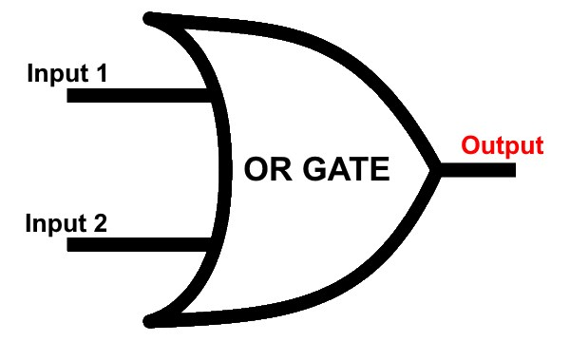 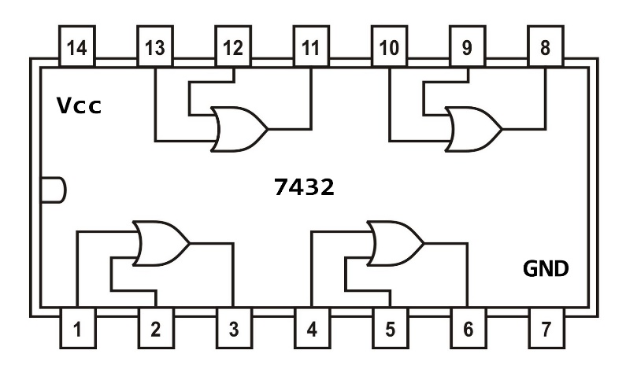

The truth table for OR operations are:

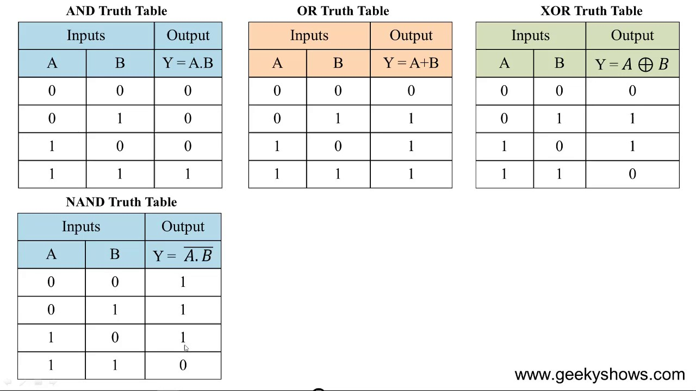

1. **AND gate:** The AND gate has two or more inputs but only one output. If any or all inputs are high then output is also high

Y = A.B

**Symbol for AND gate** **Pin Diagram For IC 7408**

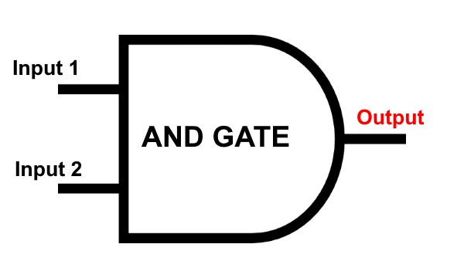 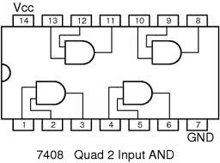

**7408**

The truth table for AND operations are:



1. **NOT gate:** The Not gate is a gate with only one input and one output. The output is always in opposite state of an input. A NOT gate is also called as Inverter because it performs inversion.

Y= $\overline{A}$

**Symbol for NOT gate** **Pin Diagram For IC 7404**

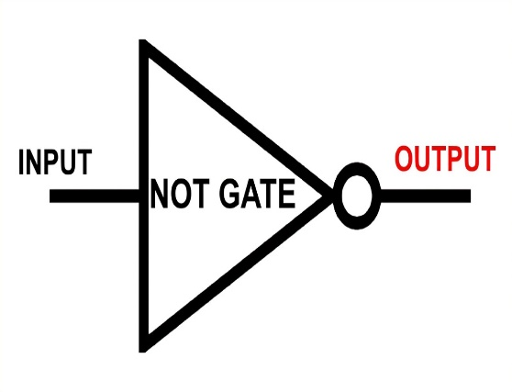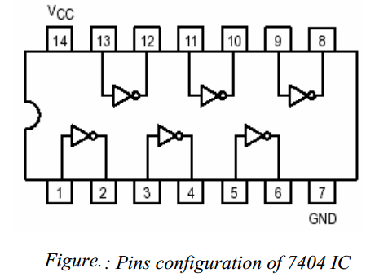

**7404**

The truth table for NOT operations is:

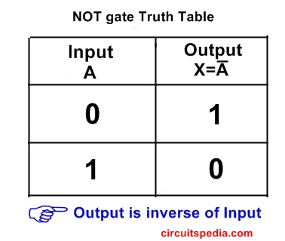

**Derived Gates/Universal Gates**

* + NAND gate
  + NOR gate
  + EX-OR gate
  + EX-NOR gate

1. **NAND gate:** This is a NOT-AND gate which is equal to an AND gate followed by a NOT gate. The outputs of all NAND gates are high if any of the inputs are low. The symbol is an AND gate with a small circle on the output. The small circle represents inversion.

Y= $\overline{A.B}$

**Symbol** **Pin Diagram for IC 7400**

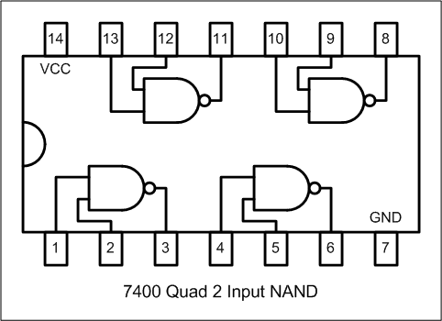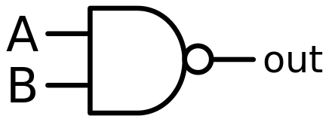

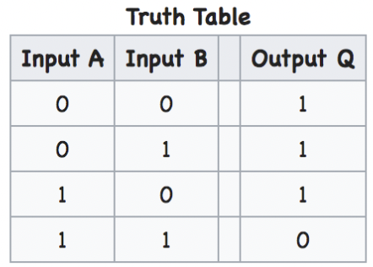The truth table for NAND operations is:

1. **NOR gate:** This is a NOT-OR gate which is equal to an OR gate followed by a NOT gate. The outputs of all NOR gates are low if any of the inputs are high. The symbol is an OR gate with a small circle on the output. The small circle represents inversion.

Y= $\overline{A+B}$

**Symbol for NOR gate** **Pin Diagram For IC 7402**

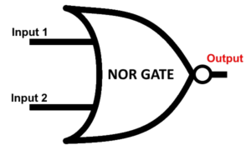 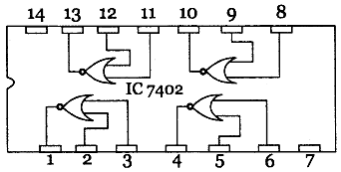

The truth table for NOR operations are:

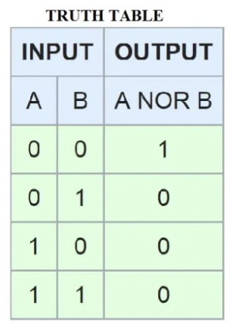

1. **EX-OR gate**: The 'Exclusive-OR' gate is a circuit which will give a high output if either, but not both, of its two inputs are high. An encircled plus sign ( ) is used to show the EX-OR operation

Y= $A⨁B$

**Symbol for Ex-OR gate** **Pin Diagram For IC 7486**

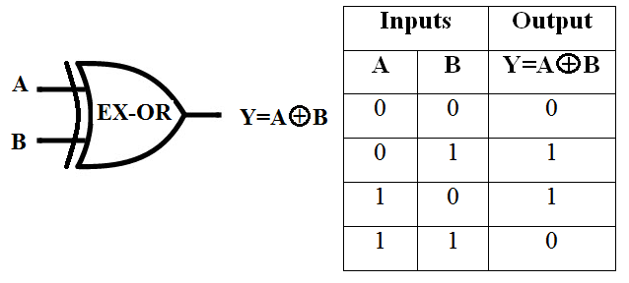 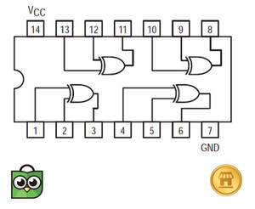

The truth table for XOR operations is:



1. **EX-NOR gate**: The 'Exclusive-NOR' gate circuit does the opposite to the EOR gate. It will give a low output if either, but not both, of its two inputs are high. The symbol is an EXOR gate with a small circle on the output. The small circle represents inversion

Y= $\overline{A⨁B}$

**Symbol for Ex-NOR gate**

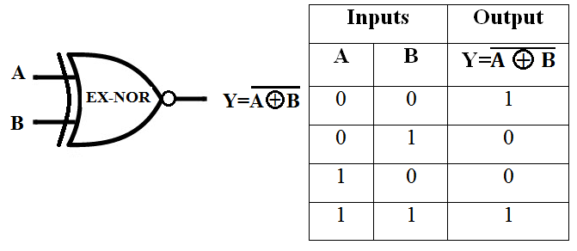

The truth table for XNOR operations is:

**Implementation Using NAND Gate**

**NOT GATE**

A NOT gate is made by joining the inputs of a NAND gate together. Since a NAND gate

is equivalent to an AND gate followed by a NOT gate, joining the inputs of a NAND gate

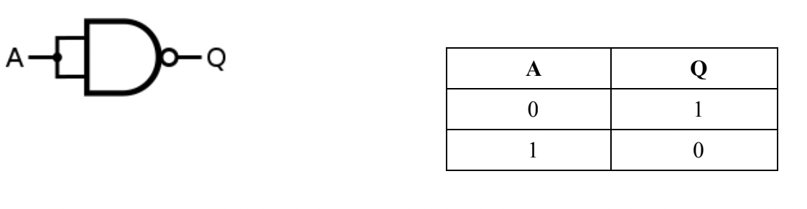leaves only the NOT gate.

**AND GATE**

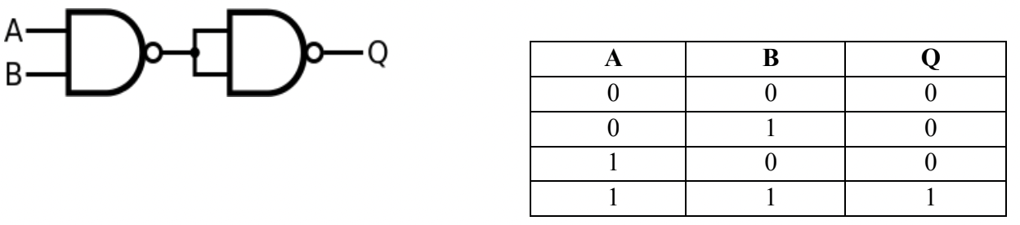An AND gate is made by inverting the output of a NAND gate as shown below.

**OR GATE**

If the truth table for a NAND gate is examined or by applying De Morgan's Laws, it can

be seen that if any of the inputs are 0, then the output will be 1. To be an OR gate,

however, the output must be 1 if any input is 1. Therefore, if the inputs are inverted,

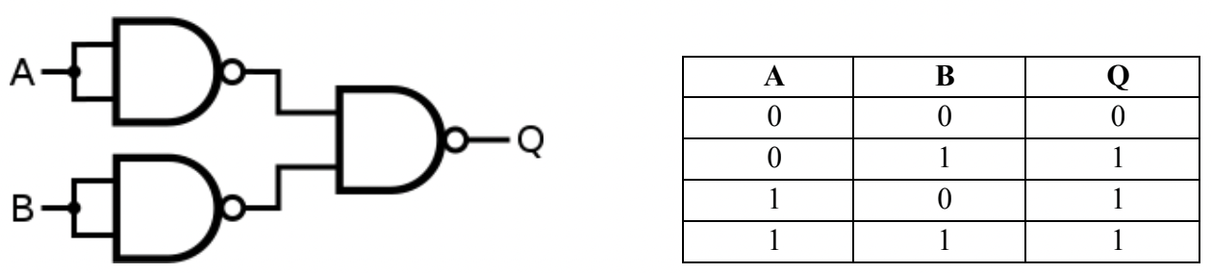any high input will trigger a high output.

**IMPLEMENTATION USING NOR GATE**

**NOT GATE**

This is made by joining the inputs of a NOR gate. As a NOR gate is equivalent to an OR gate

leading to NOT gate, this automatically sees to the "OR" part of the NOR gate, eliminating

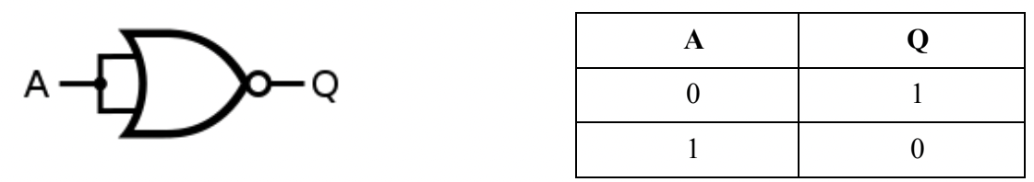it from consideration and leaving only the NOT part.

**AND GATE**

An AND gate gives a 1 output when both inputs are 1. Therefore, an AND gate is made

by inverting the inputs of a NOR gate. Again, note that a NOT gate is equivalent to a NOR

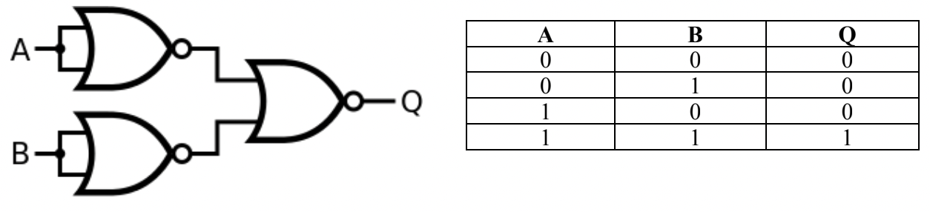with its inputs joined.

**OR GATE**

An OR gate is made by inverting the output of a NOR gate. Note that we already know that a NOT gate isequivalent to a NOR gate with its inputs joined.

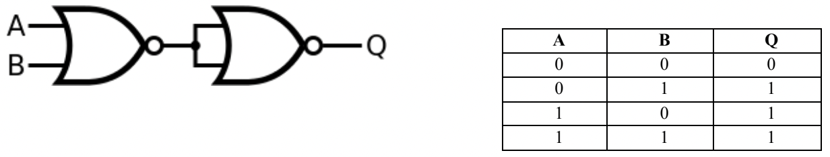

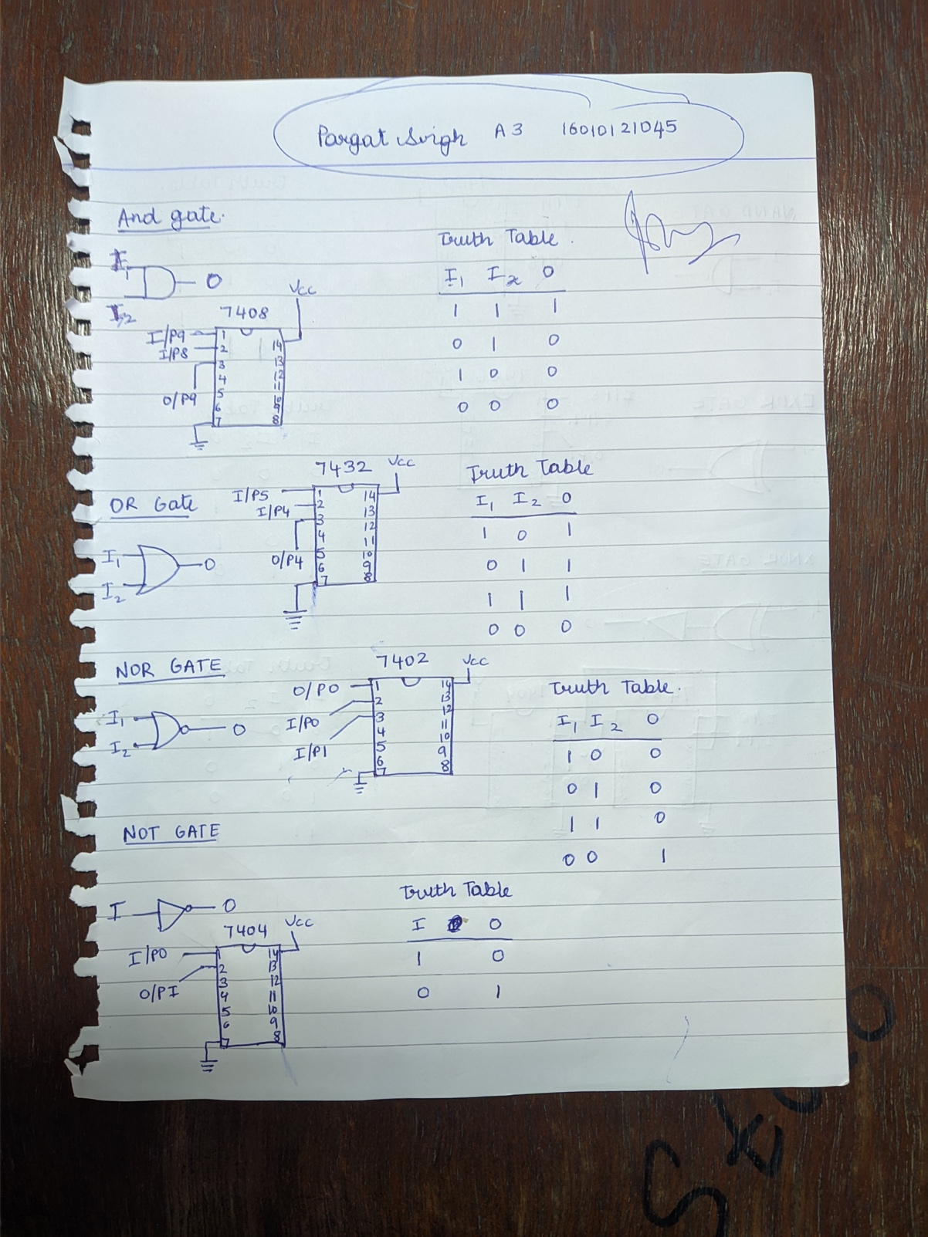**Lab Work:**

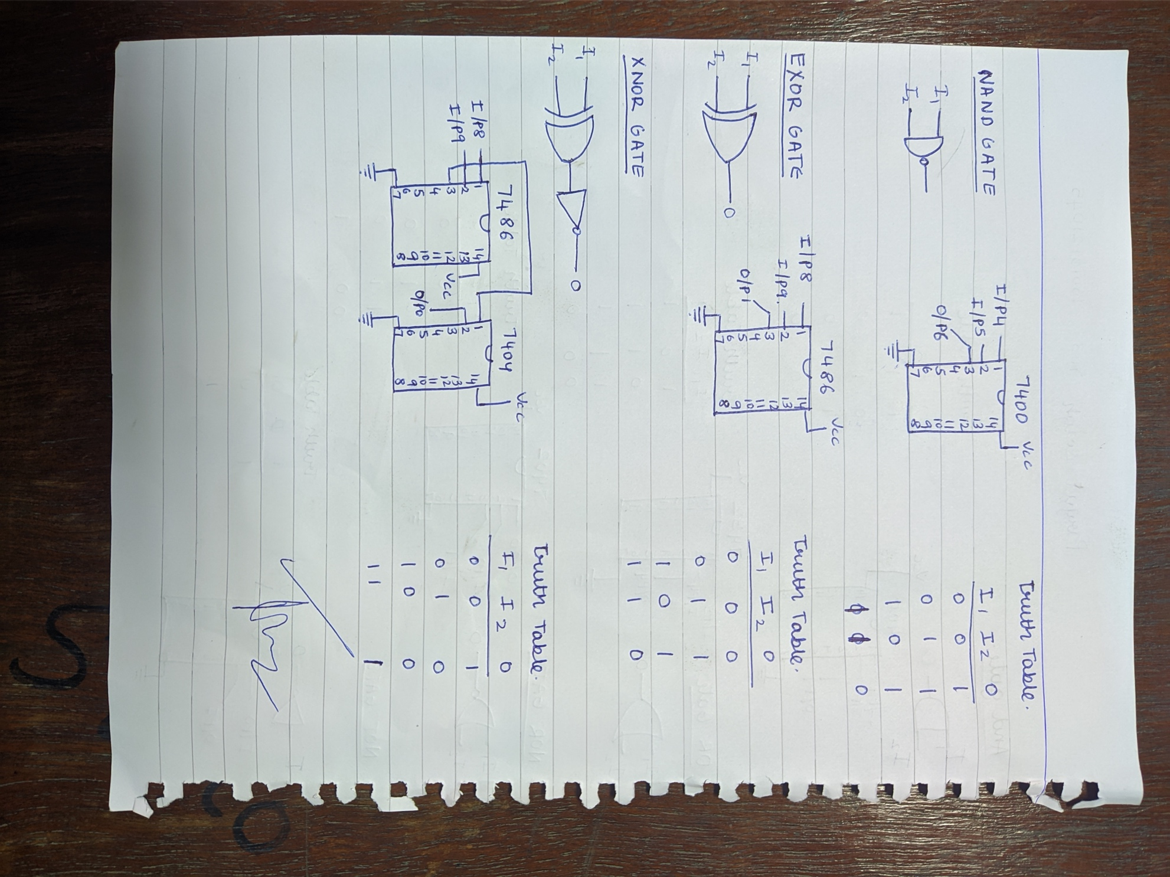

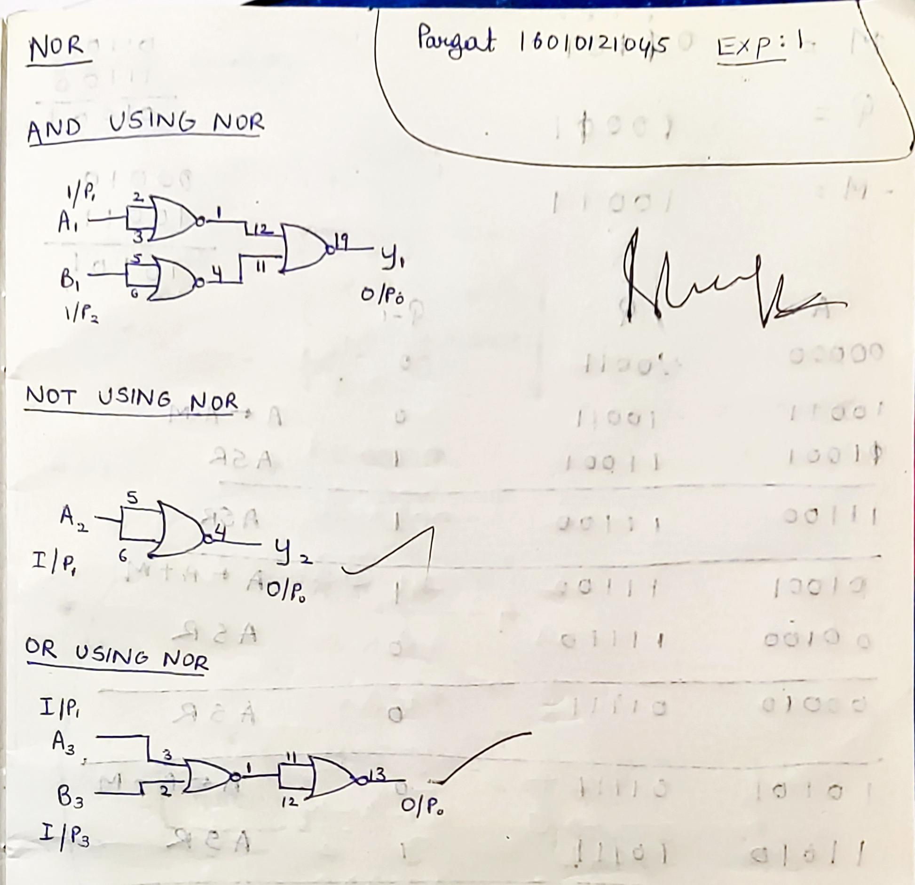

**Conclusion:**

Studied about logic gates and how they work in combinations. The basic gates: AND, OR, NOT and universal gates: NAND, NOR, XOR, XNOR

**Post Lab Descriptive Questions**

1. Verify the expression (A∙B)' + C by:
2. Using NAND Gate directly.
3. Using AND & NOT gate consecutively.

**Truth Table**

|  |  |  |  |  |  |
| --- | --- | --- | --- | --- | --- |
| A | B | C | A.B | (A.B)’ | (A.B)’ + C |
| 0 | 0 | 0 | 0 | 1 | 1 |
| 0 | 0 | 1 | 0 | 1 | 1 |
| 0 | 1 | 0 | 0 | 1 | 1 |
| 0 | 1 | 1 | 0 | 1 | 1 |
| 1 | 0 | 0 | 0 | 1 | 1 |
| 1 | 0 | 1 | 0 | 1 | 1 |
| 1 | 1 | 0 | 1 | 0 | 0 |
| 1 | 1 | 1 | 1 | 0 | 1 |

1. Using NAND Gate directly

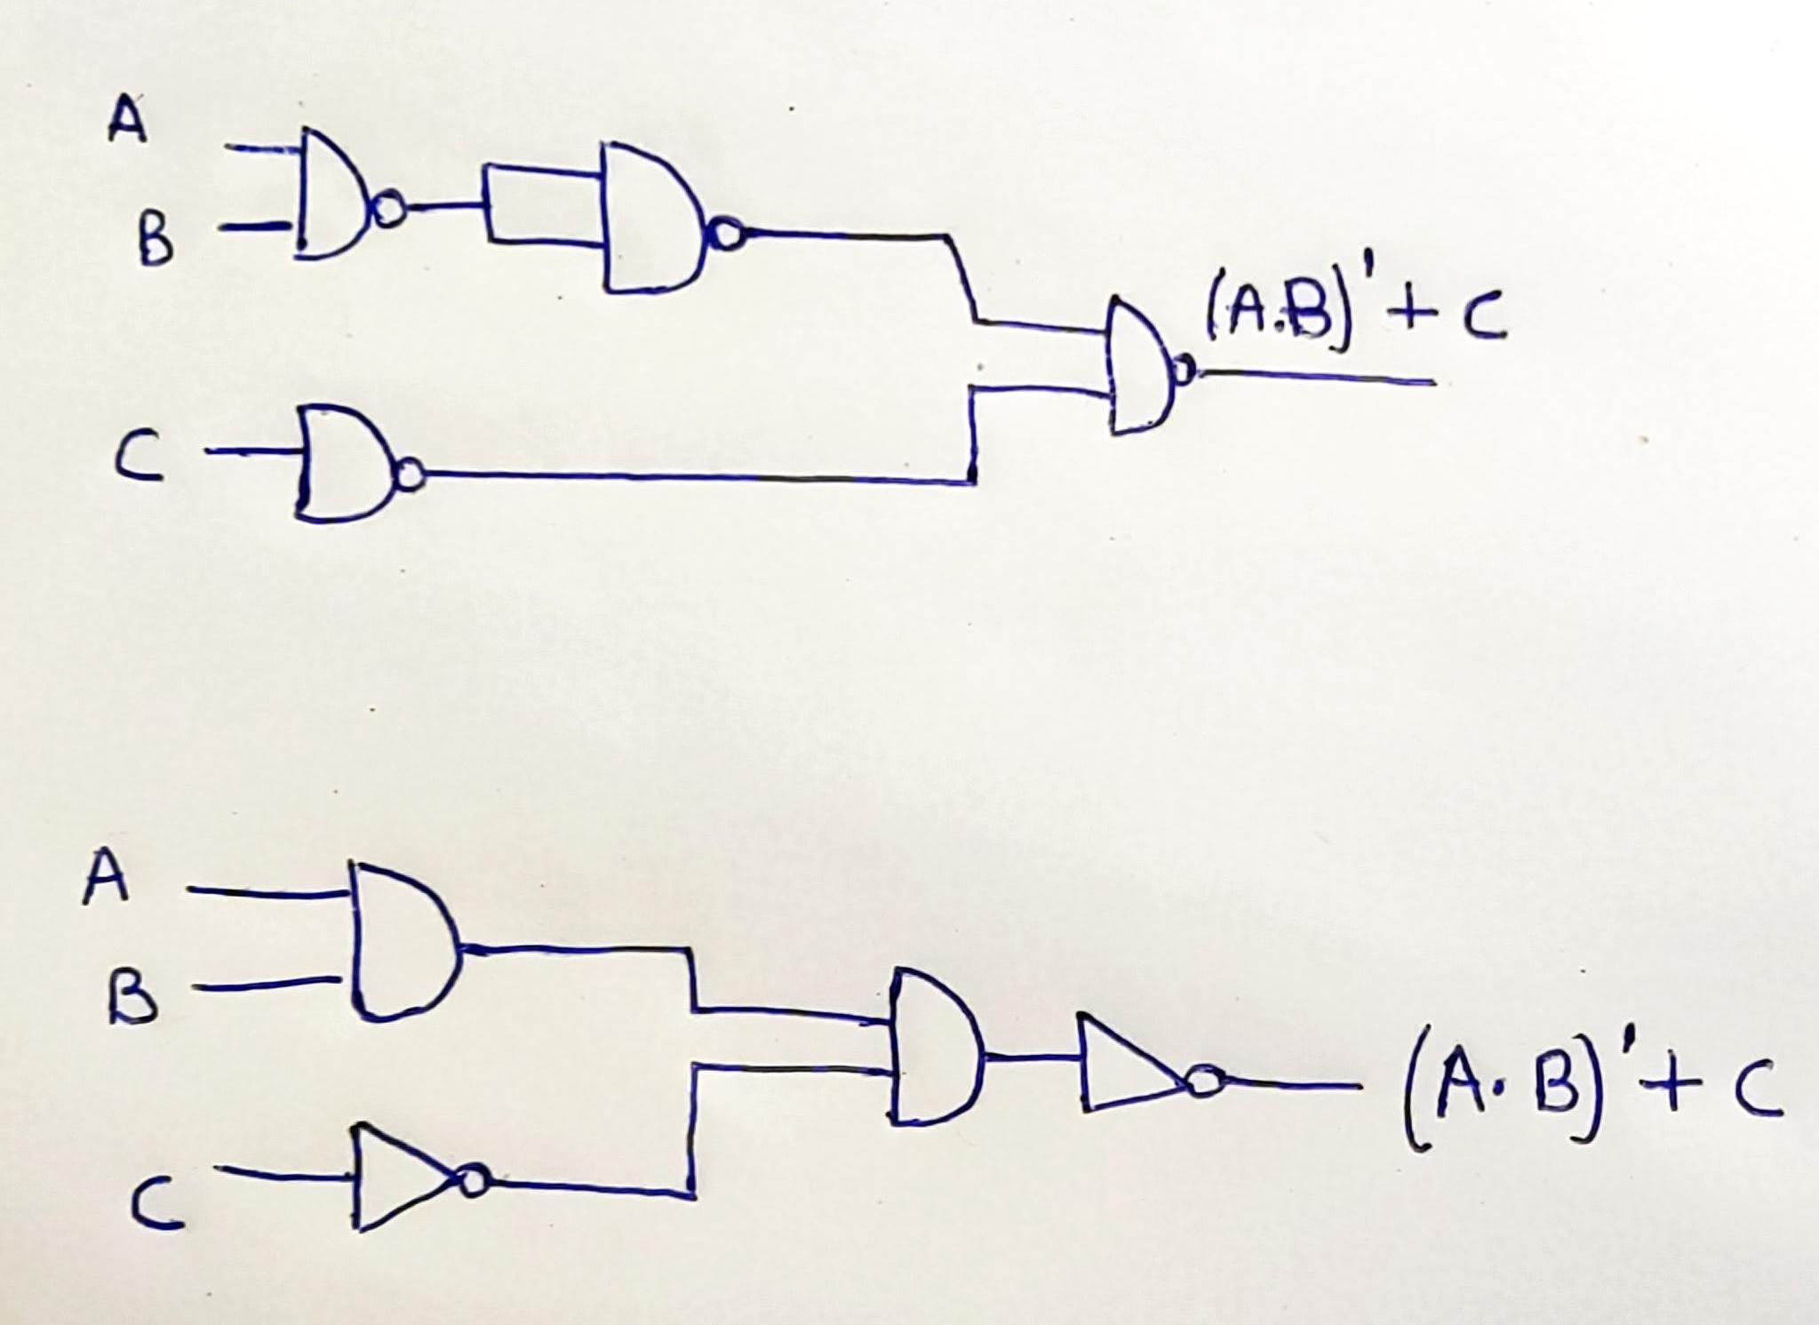

1. Using AND & NOT gate consecutively.



1. Implement the following expressions using combination of gates:
2. (A'+B)∙B

**Truth Table**

|  |  |  |  |  |
| --- | --- | --- | --- | --- |
| A | B | A’ | A’+B | (A’+B).B |
| 0 | 0 | 1 | 1 | 0 |
| 0 | 1 | 1 | 1 | 1 |
| 1 | 0 | 0 | 0 | 0 |
| 1 | 1 | 0 | 1 | 1 |

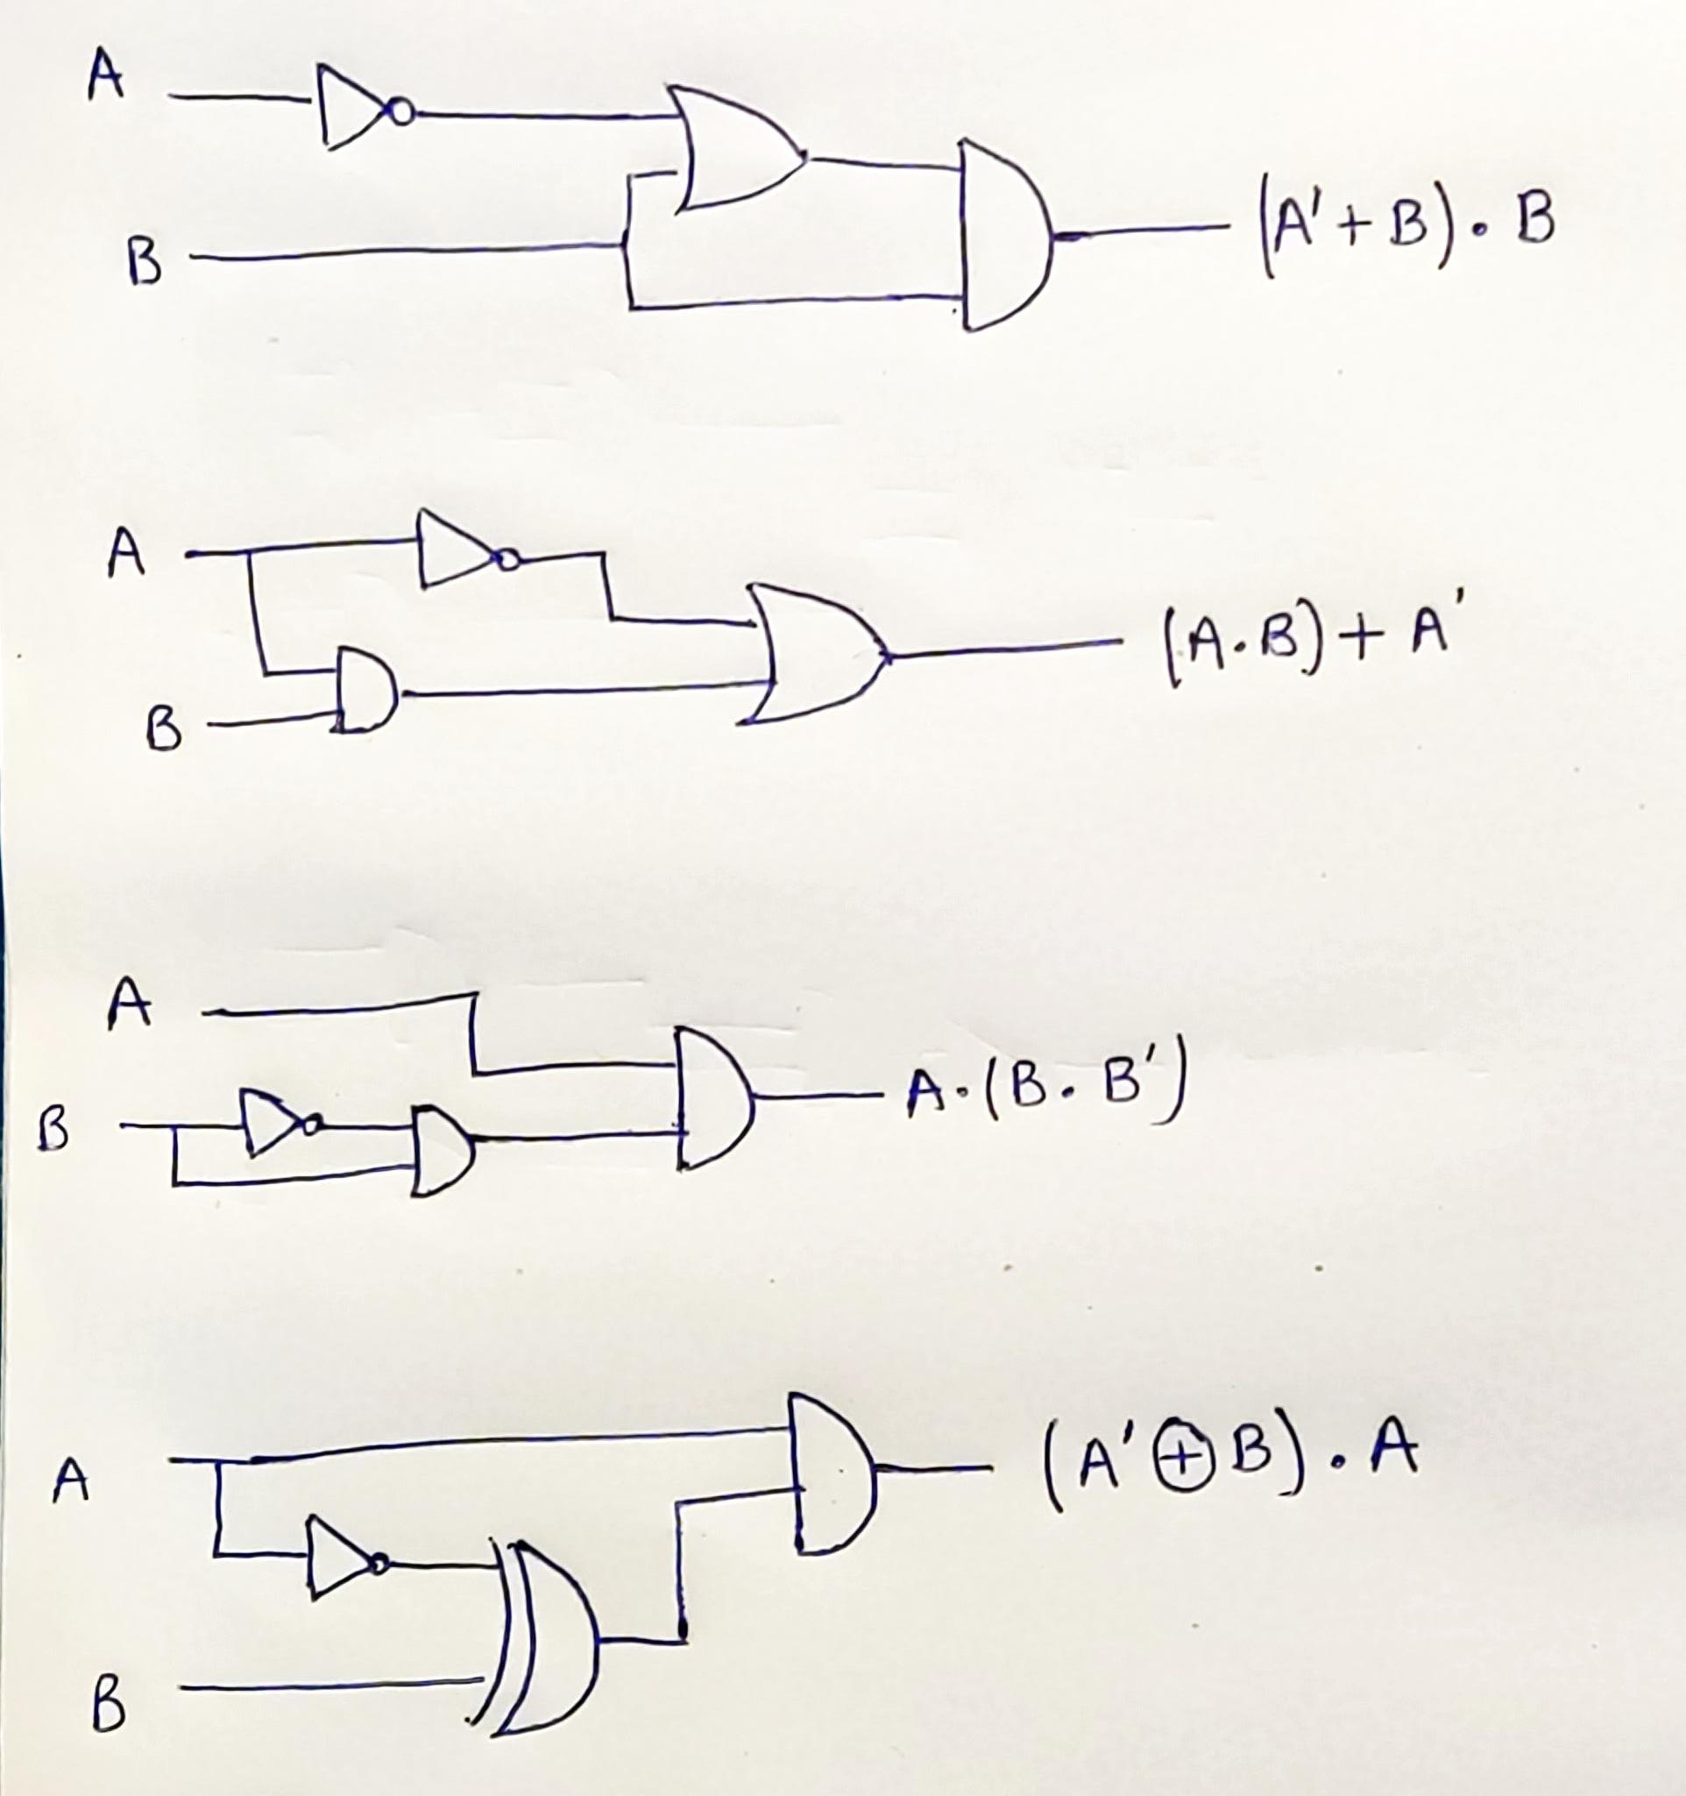

1. (A∙B)+A'

**Truth Table**

|  |  |  |  |  |
| --- | --- | --- | --- | --- |
| A | B | A’ | A.B | (A.B) + A’ |
| 0 | 0 | 1 | 0 | 1 |
| 0 | 1 | 1 | 0 | 1 |
| 1 | 0 | 0 | 0 | 0 |
| 1 | 1 | 0 | 1 | 1 |



1. A∙ (B∙B')

**Truth Table**

|  |  |  |  |  |
| --- | --- | --- | --- | --- |
| A | B | B’ | B.B’ | A.(B.B’) |
| 0 | 0 | 1 | 0 | 0 |
| 0 | 1 | 0 | 0 | 0 |
| 1 | 0 | 1 | 0 | 0 |
| 1 | 1 | 0 | 0 | 0 |



1. (A'⊕B)∙A

**Truth Table**

|  |  |  |  |  |
| --- | --- | --- | --- | --- |
| A | B | A’ | A’ ⨁ B | (A’ ⨁ B).A |
| 0 | 0 | 1 | 1 | 0 |
| 0 | 1 | 1 | 0 | 0 |
| 1 | 0 | 0 | 0 | 0 |
| 1 | 1 | 0 | 1 | 1 |



**Experiment / Assignment / Tutorial No. 2**

**Grade: AA / AB / BB / BC / CC / CD /DD**

**Signature of the Staff In-charge with date**

|  |
| --- |
| B**atch: A3 Roll No.: 16010121045 Experiment / assignment / tutorial No.: 2** |

|  |
| --- |
| **Title:** Binary Adders and Subtractors |

**_____________________________________________________________________________________**

**Objective:** To implement half and full adder–subtractor using gates and IC 7483

**______________________________________________________________________**________

**Expected Outcome of Experiment:**

**CO2:** Use different minimization technique and solve combinational circuits, synchronous & asynchronous sequential circuits.

**______________________________________________________________________________**

**Books/ Journals/ Websites referred:**

* **VLab Link:** <http://vlabs.iitb.ac.in/vlabs-dev/labs/dldesignlab/experimentlist.html>
* R. P. Jain, “Modern Digital Electronics”, Tata McGraw Hill
* M .Morris Mano, “Digital Logic & computer Design”, PHI
* http://physics.niser.ac.in/labmanuals/sem5/elect/7_ADDER%20SUBTRACTO  [R%20CIRCUITS.pd](http://physics.niser.ac.in/labmanuals/sem5/elect/7_ADDER%20SUBTRACTOR%20CIRCUITS.pdf)f

**Pre Lab/ Prior Concepts:**

**Adder:** Addition of two binary digits is most basic operation performed by the digital computer. There are two types of adder:

* Half adder
* Full adder

**Half Adder:** Half adder is combinational logic circuit with two inputs and two outputs. It is the basic building block for addition of two single bit numbers.

**Full adder:** A half adder has a provision not to add a carry coming from the lower order bits when multi bit addition is performed. for this purpose a third input terminal is added and this circuits is to add A,B,C where A and B are the nth order bits of the number A and B respectively and C is the carry generated from the addition of (n-1) order bits. This circuit is referred to as full adder.

**Subtractor:** Subtraction of two binary digits is one of the most basic operations performed by digital computer .there are two types of subtractor:

* Half subtractor
* Full subtractor

**Half subtractor:** Logic circuit for the subtraction of B from A where A,B are 1 bit numbers is referred to as half subtract or .the subtract or process has two input and difference and borrow are the two outputs.

**Full subtractor:** As in the case of the addition using logic gates, a full subtractor is made by combining two half-sub tractors and an additional OR-gate. A full subtractor has the borrow in capability (denoted as BORIN) and so allows cascading which results in the possibility of multi-bit subtraction.

**IC 7483**

For subtraction of one binary number from another, we do so by adding 2’s complement of the former to the latter number using a full adder circuit.

IC 7483 is a 16 pin, 4-bit full adder. This IC has a provision to add the carry output to transfer and end around carry output using Co and C4 respectively.

**2’s complement:** 2’s complement of any binary no. can be obtained by adding 1 in 1’scomplement of that no.

e.g. 2’s complement of +(10)10 =1010is

|  |  |  |  |
| --- | --- | --- | --- |
| 1C of 1010 |  | | 0101 |
|  |  | + | 1 |
| -(10)10 |  | | 0110 |

In 2’s complement subtraction using IC 7483, we are representing negative number in 2’s complement form and then adding it with 1st number.

**Implementation Details:**

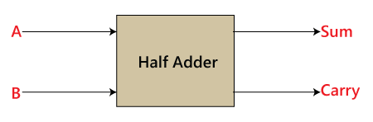**Half Adder Block Diagram**

**Half Adder Circuit**

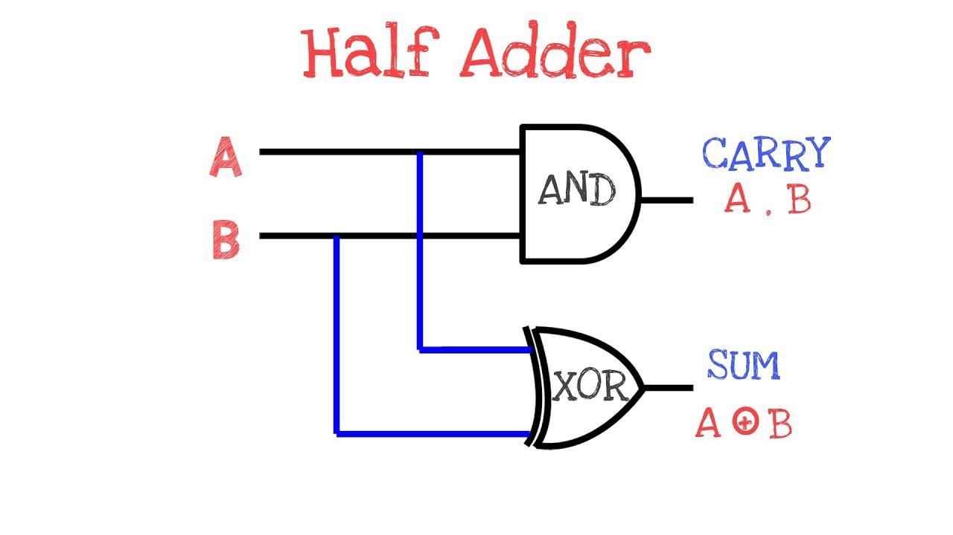**Truth Table for Half Adder**

|  |  |  |  |
| --- | --- | --- | --- |
| **Inputs** | | **Outputs** | |
| **A** | **B** | **A** | **B** |
| 0 | 0 | 0 | 0 |
| 0 | 1 | 0 | 1 |
| 1 | 0 | 1 | 0 |
| 1 | 1 | 1 | 1 |

**From the truth table (with steps):**

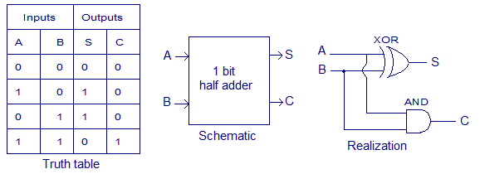

**Full Adder Block Diagram**

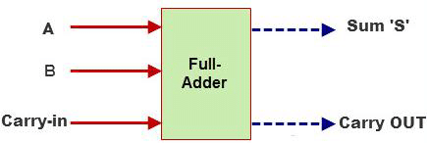

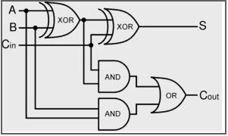**Full Adder Circuit**

**Truth Table for Full Adder**

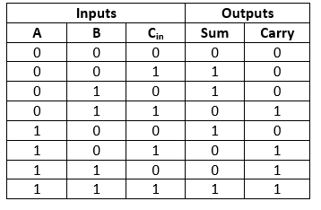

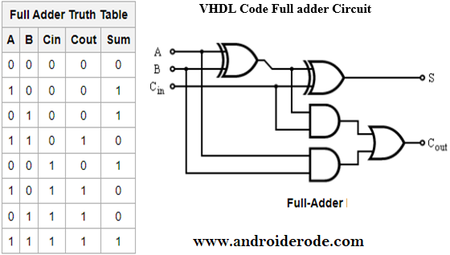**From the truth table (with steps):**



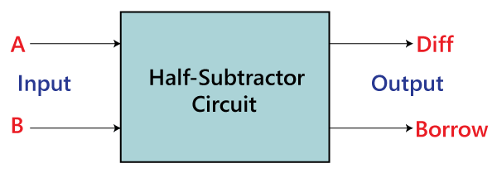**Half Subtractor Block Diagram**

**Half Subtractor Circuit**

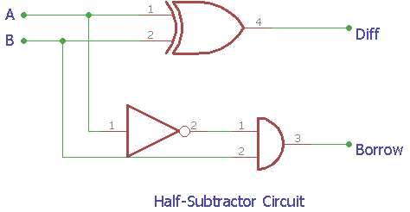

**Truth Table for Half Subtractor**

|  |  |  |  |  |
| --- | --- | --- | --- | --- |
|  |  |  |  |  |
| **A** | **B** | **DIFFERENCE(D)** | **BORROW(Bo)** |  |
|  |  |  |  |  |
| 0 | 0 | 0 | 0 |  |
|  |  |  |  |  |
| 0 | 1 | 1 | 1 |  |
|  |  |  |  |  |
| 1 | 0 | 1 | 0 |  |
|  |  |  |  |  |
| 1 | 1 | 0 | 0 |  |
|  |  |  |  |  |

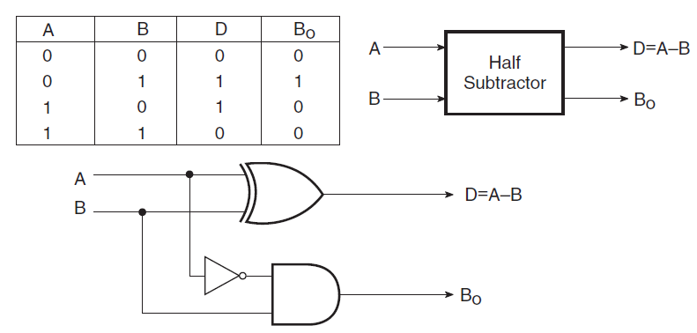**From the truth table (with steps) :**

**Full Subtractor Block Diagram**

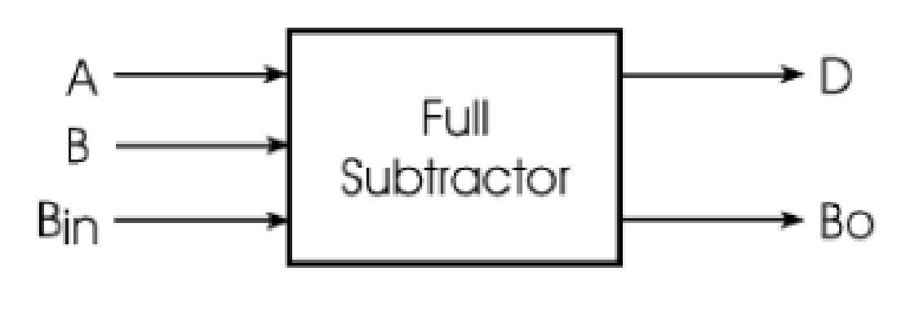

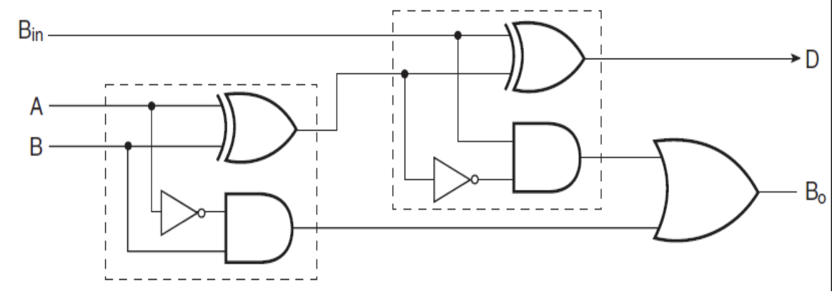**Full Subtractor Circuit**

**Truth Table for Full subtractor**

|  |  |  |  |  |
| --- | --- | --- | --- | --- |
| **A** | **B** | **BIN** | **D** | **BOROUT** |
| 0 | 0 | 0 | 0 | 0 |
| 0 | 0 | 1 | 1 | 1 |
| 0 | 1 | 0 | 1 | 1 |
| 0 | 1 | 1 | 0 | 1 |
| 1 | 0 | 0 | 1 | 0 |
| 1 | 0 | 1 | 0 | 0 |
| 1 | 1 | 0 | 0 | 0 |
| 1 | 1 | 1 | 1 | 1 |

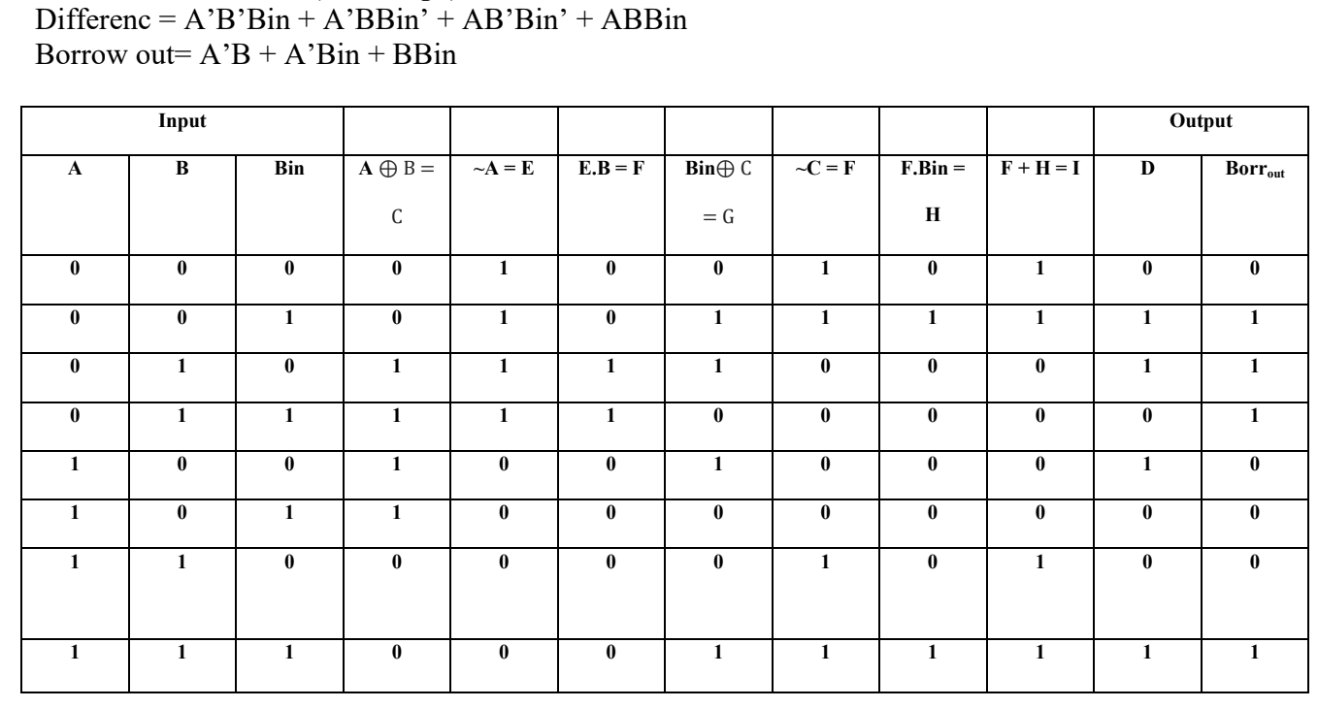**From the truth table (with steps):**

**IC 7483**

**Procedure:**

1. Locate the IC 7483 and 4-not gates block on trainer kit.
2. Connect 1st input no. to A4-A1 input slot and 2nd (negative) no. to B4-B1 through 4-not gates (1C of 2nd no.)
3. Connect high input to Co so that it will get added with 1C of 2nd no. to get 2C.
4. Connect 4-bit output to the output indicators.
5. Switch ON the power supply and monitor the output for various input combinations.

**Example:**

|  |  |  |
| --- | --- | --- |
| 1) 710 -210 = 510 | |  |
| 7 |  | 0111 |
| 2 |  | 0010 |
| 1’C of 2 | | 1101 |
|  |  | + 1 |
| 2’C of 2 | | 1110 |

0111 + 1110 1 0101

**Pin Diagram IC7483**

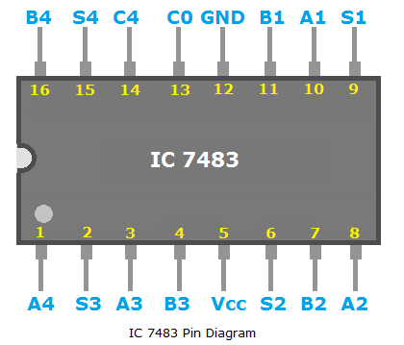

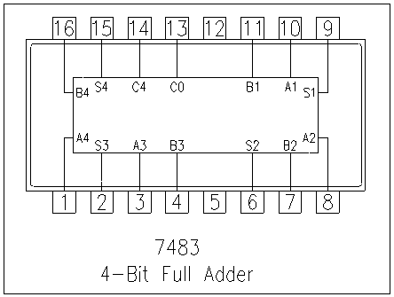**Adder**

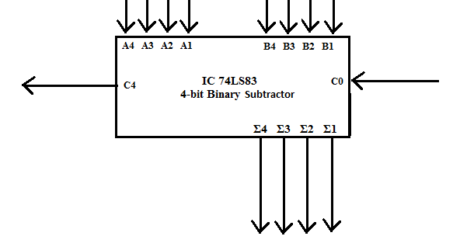**Subtractor**

**Conclusion:** Thus the circuits of binary adder and sub tractors were studied on the IC kit using

Connectors and tested using sample values.

**Post Lab Descriptive Questions**

1. What is difference between half and full adder, half and full subtractor?
2. Difference between half and full adder

|  |  |
| --- | --- |
| **Half Adder** | **Full Adder** |
| Half adder accepts two binary digits on it’s inputs and produce two binary digits  outputs, a sum bit and a carry bit | The full adder accepts two input bits and an  input carry and generates a sum output and  an output carry |
| Half adder is easier to implement. | It is more difficult as it needs two half  adders to implement |
| Half adder can add only two input bits (A  and B) and has nothing to do with carry if  there is only one input, that means the  binary addition process is not complete, thus  it is called half adder. | Full adder can add a 3 bit number (A,B,Cin)  A and B are the operands and Cin is the  carry from the previous less significant  stage. |

B) Difference between half and full subtractor

|  |  |
| --- | --- |
| **Half Subtractor** | **Full Subtractor** |
| 1. It is a combinational circuit which is  used to perform subtraction of two bits | 1. It is a combinational circuit which is used to  perform subtraction of three bits |
| 2. It has two inputs (A,B) and two output  D(Difference) and B(Borrow). | 2. It has input A(number) B(subtractor) and Bin  (Borrow) from previous stage. And the  outputs are D (Difference) and B (Borrow) |
| 3.  Truth table :   |  |  |  |  | | --- | --- | --- | --- | | A | B | D | B | | 0 | 0 | 0 | 0 | | 0 | 1 | 1 | 1 | | 1 | 0 | 1 | 0 | | 1 | 1 | 0 | 0 | | 3.  Truth table:   |  |  |  |  |  | | --- | --- | --- | --- | --- | | A | B | Bin | D | Bout | | 0 | 0 | 0 | 0 | 0 | | 0 | 0 | 1 | 1 | 1 | | 0 | 1 | 0 | 1 | 1 | | 0 | 1 | 1 | 0 | 1 | | 1 | 0 | 0 | 1 | 0 | | 1 | 0 | 1 | 0 | 0 | | 1 | 1 | 0 | 0 | 0 | | 1 | 1 | 1 | 1 | 1 | |

1. **Perform the following Binary subtraction with the help of appropriate ICs:**
2. **7-5**

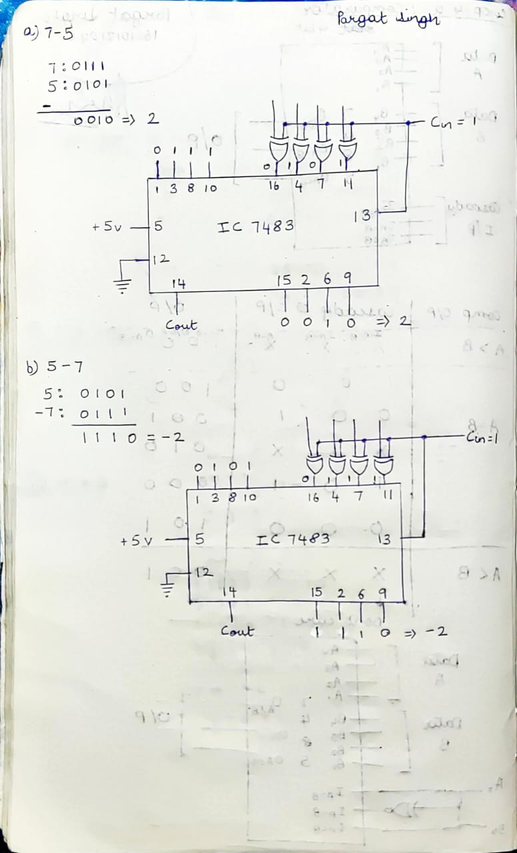

1. **5-7**



1. **9-4**

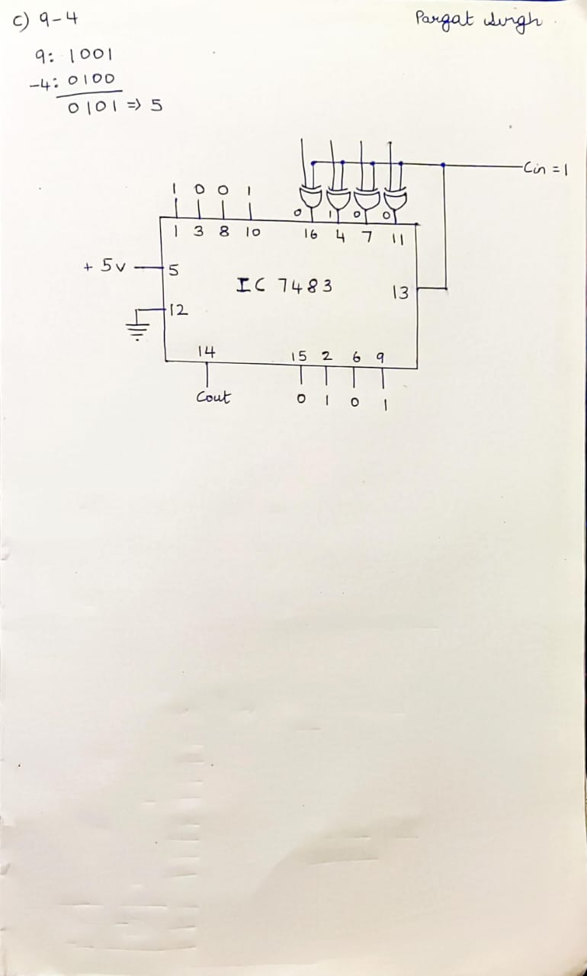

**Lab Work:**

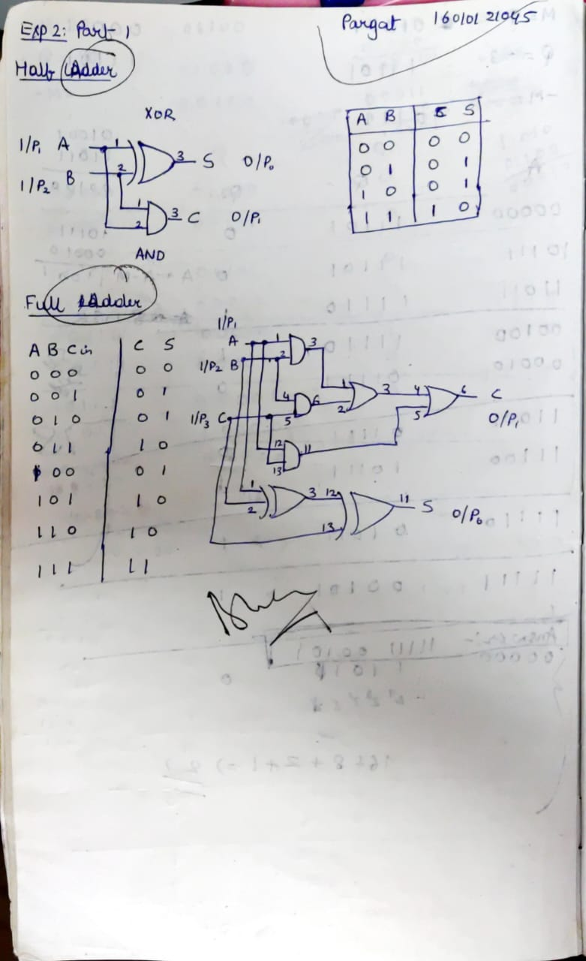

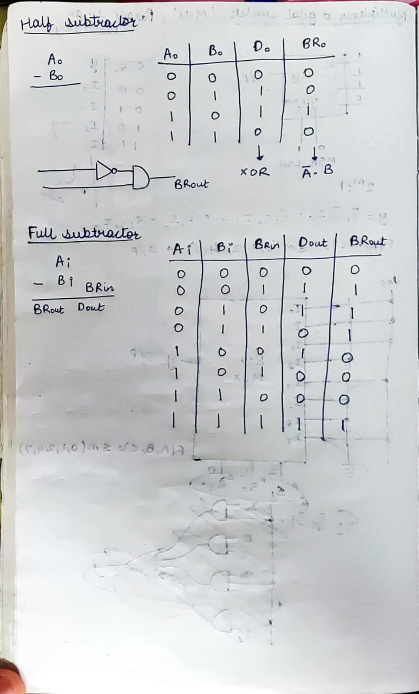

**Experiment / Assignment / Tutorial No. 3**

**Grade: AA / AB / BB / BC / CC / CD /DD**

**Signature of the Staff In-charge with date**

|  |
| --- |
| **Batch: A3 Roll No.: 16010121045 Experiment / assignment / tutorial No.: 3** |

|  |
| --- |
| **Title:** Design 4:1 Multiplexer and 1: 4 De-multiplexer |

**______________________________________________________________________________**

**Objective:** To design and implement a 4:1 multiplexer and 1:4 de-multiplexer using logic gates and MUX IC

**______________________________________________________________________________**

**Expected Outcome of Experiment:**

**CO2:** Use different minimization technique and solve combinational circuits, synchronous & asynchronous sequential circuits.

**______________________________________________________________________________**

**Books/ Journals/ Websites referred:**

* VLab Links: <http://vlabs.iitb.ac.in/vlabs-dev/labs/dldesignlab/experimentlist.html>
* R. P. Jain, “Modern Digital Electronics”, Tata McGraw Hill
* M .Morris Mano, “Digital Logic & computer Design”, PHI
* [https://wiki.engr.illinois.edu/download/attachments/84770821/08](https://wiki.engr.illinois.edu/download/attachments/84770821/08-Multiplexers.pdf?version=2&modificationDate=1285128827000)- [Multiplexers.pdf?version=2&modificationDate=128512882700](https://wiki.engr.illinois.edu/download/attachments/84770821/08-Multiplexers.pdf?version=2&modificationDate=1285128827000)0

**Pre Lab/ Prior Concepts:**

**Multiplexer:** Multiplexer is a special type of combinational circuit. It is a digital circuitwhich selects one of the n data inputs and routes it to the output. The selection of one of the n inputs is done by the select lines. To select n inputs we require m select lines, such that 2m=n. Depending on the digital code applied at the select inputs, one out of the n data sources is selected and transmitted to a single output . E is called as the strobe or enable input which is useful for cascading. It is generally on active low terminal that means it will perform the required operation when it is low. The multiplexer act like a digitally controlled single pole, multiple way switches. The output gets connected to only one input at a time. In most of the electronic system the digital data is available on more than one line. It is necessary to route the data over a single line, under such circumstances input at a time

**Types of Multiplexer:**

1. 2:1 Multiplexer
2. 4:1 Multiplexer
3. 8:1 Multiplexer
4. 16:1 Multiplexer
5. 32:1 Multiplexer

**De-multiplexer:** It has only one input, n output and m select lines. A demultiplexerperforms the reverse operation of a multiplexer i.e. it receives one input and distributes it over several outputs. The demultiplexer converts a serial data signal at the input to a parallel data at its output lines. The relation between the output lines and select lines is as follows: N=2m

**Types of Demultiplexers:**

1. 1:2 DEMUX
2. 1:4 DEMUX
3. 1:8 DEMUX
4. 1:16 DEMUX

**Implementation Details of 4:1 MUX**

**Block Diagram of 4:1 MUX**

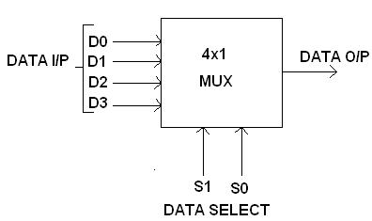

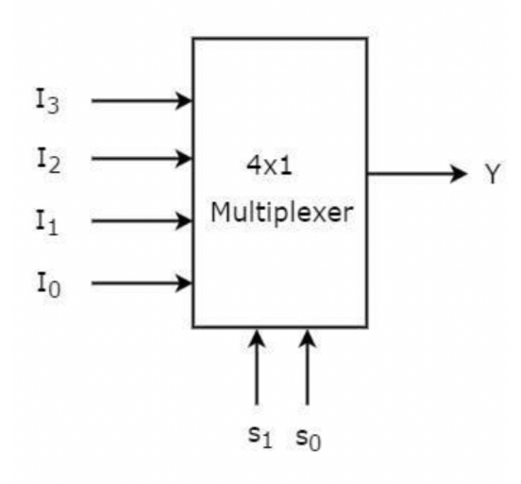

**Circuit Diagram of 4:1 MUX**

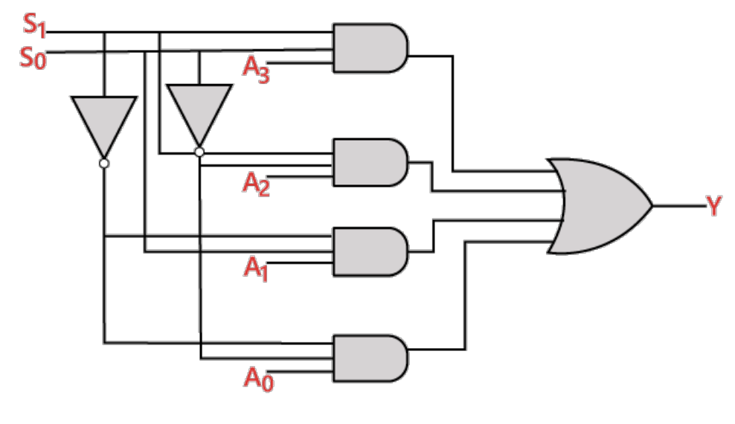

**Truth table**

|  |  |  |
| --- | --- | --- |
| **S1** | **S0** | **Y** |
| 0 | 0 | D0 |
| 0 | 1 | D1 |
| 1 | 0 | D2 |
| 1 | 1 | D3 |

**From Truth Table:**

Y = S1' S0' D0+S1' S0 D1+S1 S0' D2+S1 S0 D3

**Implementation Details of 8:1 MUX**

**Circuit Diagram of 8:1 MUX**

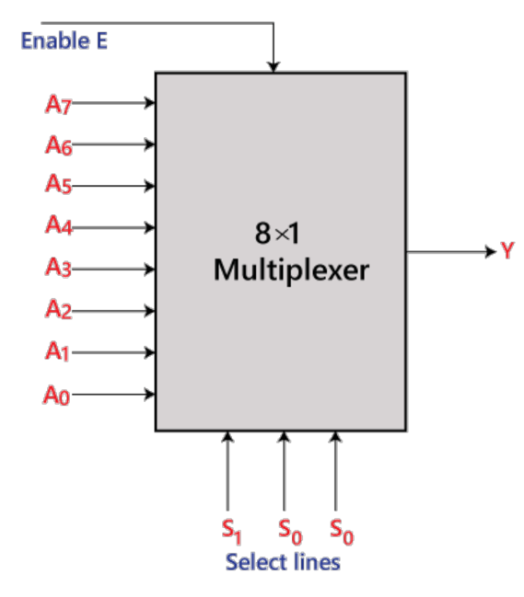

**Truth Table for 8:1 Multiplexer**

|  |  |  |  |
| --- | --- | --- | --- |
| **S2** | **S1** | **S0** | **Y** |
| 0 | 0 | 0 | D0 |
| 0 | 0 | 1 | D1 |
| 0 | 1 | 0 | D2 |
| 0 | 1 | 1 | D3 |
| 1 | 0 | 0 | D4 |
| 1 | 0 | 1 | D5 |
| 1 | 1 | 0 | D6 |
| 1 | 1 | 1 | D7 |

**From Truth Table:**

**Y =** S0'.S1'.S2'.D0+S0.S1'.S2'.D1+S0'.S1.S2'.D2+S0.S1.S2'.D3+S0'.S1'.S2 D4+S0.S1'.S2 D5 +S0'.S1.S2 .D6+S0.S1.S3.D7

**Pin diagram: IC 74151**

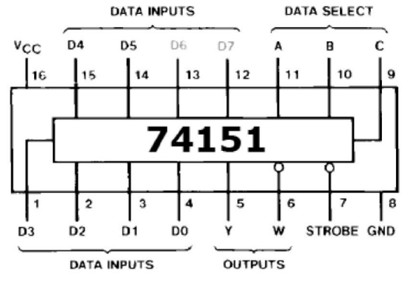

**Block Diagram of 1:4 DE MUX**

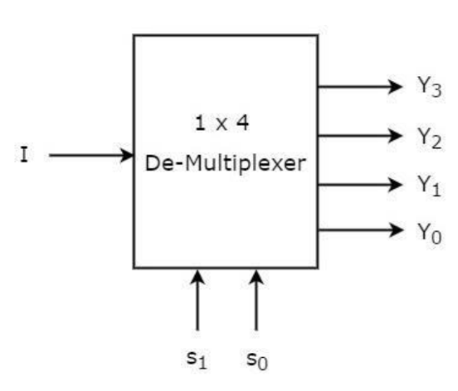

**Circuit Diagram of 1:4 DE MUX**

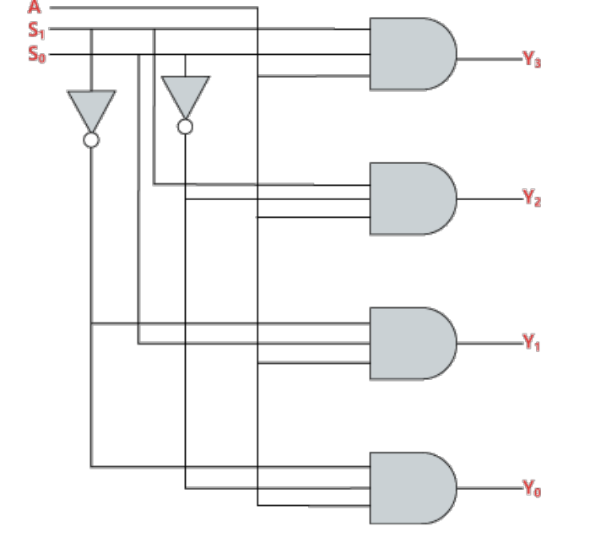

**Truth Table for 1:4 Demultiplexers**

|  |  |  |  |  |  |
| --- | --- | --- | --- | --- | --- |
| **B** | **A** | **Y0** | **Y1** | **Y2** | **Y3** |
| 0 | 0 | D | 0 | 0 | 0 |
| 0 | 1 | 0 | D | 0 | 0 |
| 1 | 0 | 0 | 0 | D | 0 |
| 1 | 1 | 0 | 0 | 0 | D |

**From Truth Table:**

D0 = A’ B’ X

D1 = A’ B X

D2 = A B’ X

D3 = A B X

**Conclusion:**

We designed and implemented a 4:1 multiplexer and 1:4 de-multiplexer using logic gates and MUX IC. Understood the concept of multiplexers and demultiplexers and implemented the same.

**Post Lab Descriptive Questions**

1. **How many select lines are required for 64:1 MUX?**

For 64:1 MUX, as per the relation 2Select Lines=Number of inputs. So, number of select line (S) that will be needed will be log2(n) where n is 64.

So, S= log2(64)=6.

1. **State some applications of MUX and DEMUX.**

Applications of Multiplexer:

1. **Communication system**: Communication system is a set of system that enables  communication like transmission system, relay and tributary station, and communication  network. The efficiency of communication system can be increased considerably using  multiplexer. Multiplexer allow the process of transmitting different type of data such as  audio, video at the same time using a single transmission line.

2. **Telephone network**: In telephone network, multiple audio signals are integrated on a  single line for transmission with the help of multiplexers. In this way, multiple audio  signals can be isolated and eventually, the desire audio signals reach the intended  recipients.

3. **Computer memory**: Multiplexers are used to implement huge amount of memory into  the computer, at the same time reduces the number of copper lines required to connect the  memory to other parts of the computer circuit.

4. **Transmission from the computer system of a satellite:** Multiplexer can be used for  the transmission of data signals from the computer system of a satellite or spacecraft to the  ground system using the GPS (Global Positioning System) satellites.

• Applications of Demultiplexer:

1. **Demultiplexer** is used to connect a single source to multiple destinations. The main  application area of demultiplexer is communication system where multiplexer are used.  Most of the communication systems are bidirectional i.e. they function in both ways  (transmitting and receiving signals). Hence, for most of the applications, the multiplexer  and demultiplexer work in sync. Demultiplexers are also used for reconstruction of parallel  data and ALU circuits.

2. **Communication System**: Communication system use multiplexer to carry multiple  data like audio, video and other form of data using a single line for transmission. This  process makes the transmission easier. The demultiplexer receives the output signals of the  multiplexer and converts them back to the original form of the data at the receiving end.  The multiplexer and demultiplexer work together to carry out the process of transmission  and reception of data in communication system.

3. **ALU (Arithmetic Logic Unit):** In an ALU circuit, the output of ALU can be stored in  multiple registers or storage units with the help of demultiplexer. The output of ALU is fed  as the data input to the demultiplexer. Each output of demultiplexer is connected to multiple  register which can be stored in the registers.

4. **Serial to parallel converter**: A serial to parallel converter is used for reconstructing  parallel data from incoming serial data stream. In this technique, serial data from the  incoming serial data stream is given as data input to the demultiplexer at the regular  intervals. A counter is attached to the control input of the demultiplexer. This counter  directs the data signal to the output of the demultiplexer where these data signals are stored.  When all data signals have been stored, the output of the demultiplexer can be retrieved and  read out in parallel.

1. **Build a 4:1 MUX using only 2:1 MUX.**

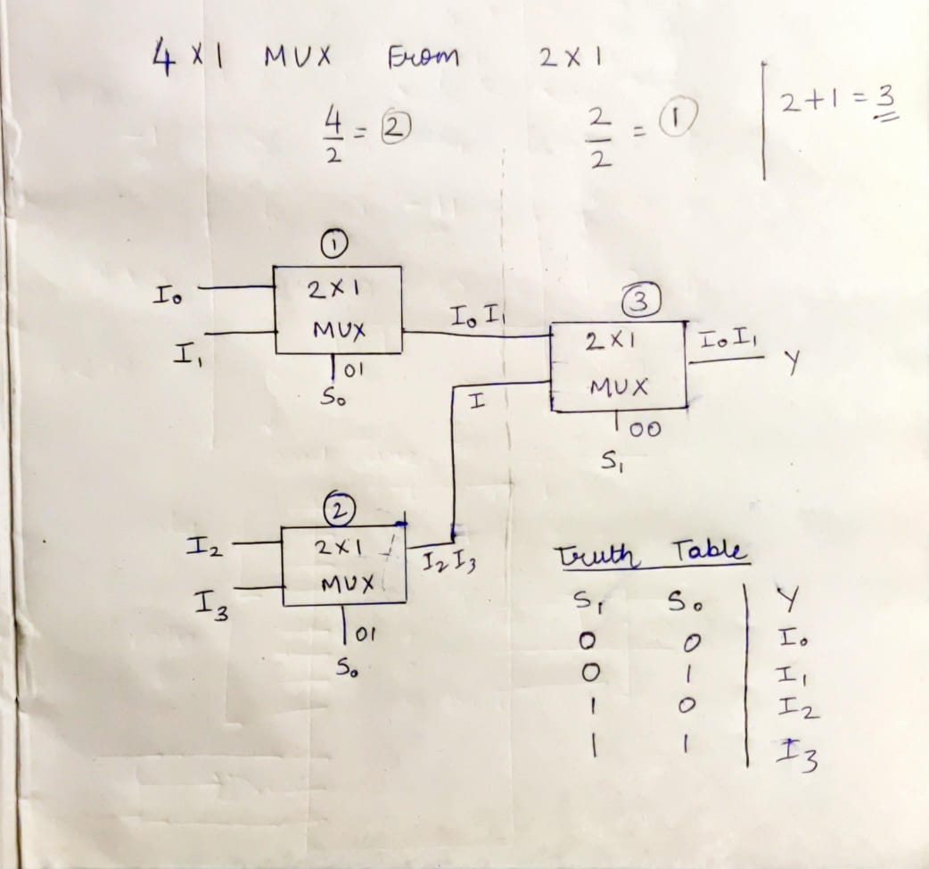

**Lab Work:**

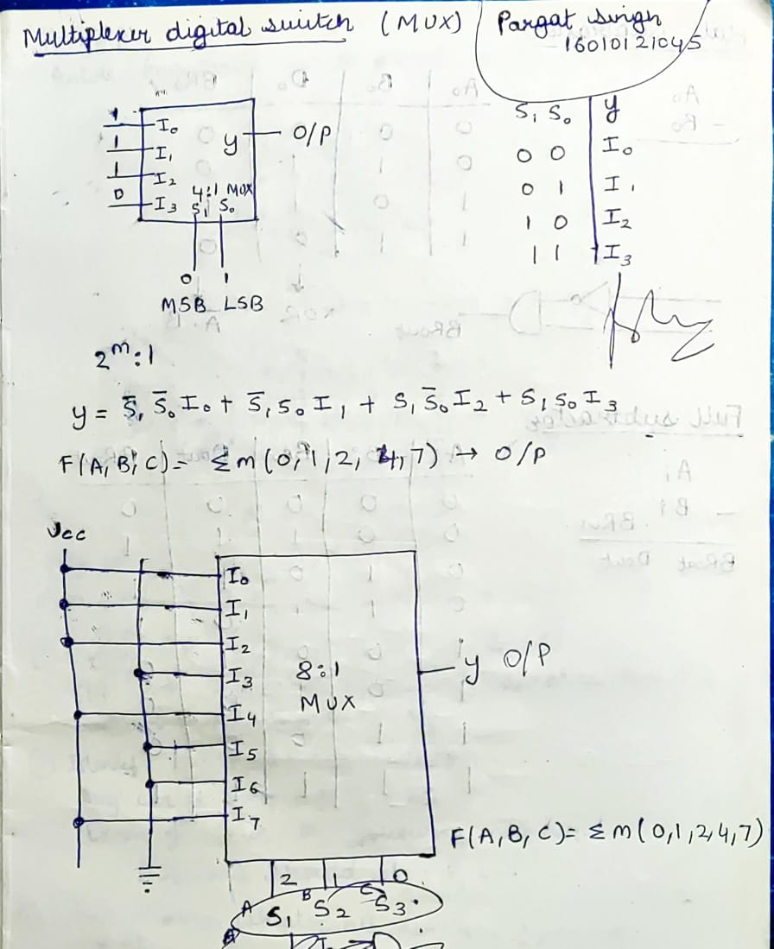

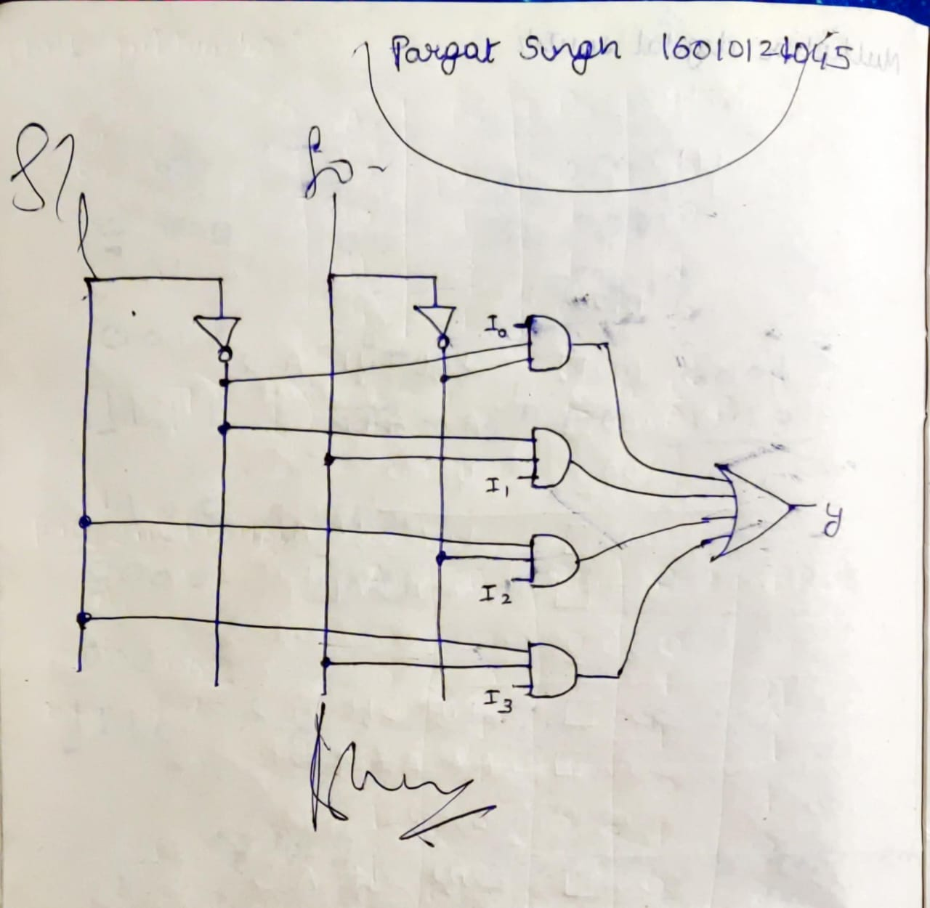

**Experiment / Assignment / Tutorial No. 4**

**Grade: AA / AB / BB / BC / CC / CD /DD**

**Signature of the Staff In-charge with date**

|  |
| --- |
| **Batch: A3 Roll No.: 16010121045 Experiment / assignment / tutorial No.: 4** |

|  |
| --- |
| **Title:** 4 bit Magnitude Comparator |

**______________________________________________________________________________**

**Objective:** Design a 2-bit comparator using logic gates and verify 4-bit magnitudecomparator using IC 7485

**_____________________________________________________________________________**

**Expected Outcome of Experiment:**

**CO2:** Use different minimization technique and solve combinational circuits, synchronous & asynchronous sequential circuits.

**______________________________________________________________________________**

**Books/ Journals/ Websites referred:**

* VLab Link: <http://vlabs.iitb.ac.in/vlabs-dev/labs/dldesignlab/experimentlist.html>
* R. P. Jain, “Modern Digital Electronics”, Tata McGraw Hill
* M .Morris Mano, “Digital Logic & computer Design”, PHI
* http://elnsite.teilam.gr/ebooks/digital_design/lab/dataSheets_page/7485.pdf

**Pre Lab/ Prior Concepts:**

The comparison of two numbers is an operator that determines one number is greater than, less than (or) equal to the other number. A magnitude comparator is a combinational circuit that compares two numbers A and B and determines their relative magnitude. The outcome of the comparator is specified by three binary variables that indicate whether A>B, A=B (or) A<B.

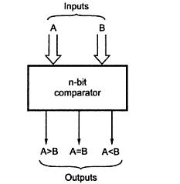

**Two Bit Magnitude Comparator Implementation Details:**

**Truth Table**

|  |  |  |  |  |  |  |
| --- | --- | --- | --- | --- | --- | --- |
| **A1** | **A0** | **B1** | **B0** | **A > B** | **A = B** | **A < B** |
| 0 | 0 | 0 | 0 | 0 | 1 | 0 |
| 0 | 0 | 0 | 1 | 1 | 0 | 0 |
| 0 | 0 | 1 | 0 | 1 | 0 | 0 |
| 0 | 0 | 1 | 1 | 1 | 0 | 0 |
| 0 | 1 | 0 | 0 | 0 | 0 | 1 |
| 0 | 1 | 0 | 1 | 0 | 1 | 0 |
| 0 | 1 | 1 | 0 | 1 | 0 | 0 |
| 0 | 1 | 1 | 1 | 1 | 0 | 0 |
| 1 | 0 | 0 | 0 | 0 | 0 | 1 |
| 1 | 0 | 0 | 1 | 0 | 0 | 1 |
| 1 | 0 | 1 | 0 | 0 | 1 | 0 |
| 1 | 0 | 1 | 1 | 1 | 0 | 0 |
| 1 | 1 | 0 | 0 | 0 | 0 | 1 |
| 1 | 1 | 0 | 1 | 0 | 0 | 1 |
| 1 | 1 | 1 | 0 | 0 | 0 | 1 |
| 1 | 1 | 1 | 1 | 0 | 1 | 0 |

**From the Truth Table:**

**(A<B) =** A1’B1 + A0’B1B0 + A1’A0’B0

**(A=B) =** (A1XORB1). (A0XORB0)

**(A>B) =** A1B1’ + A0B1’B0’ + A1A0B0’

**Logic Diagram of 2 bit Comparator**

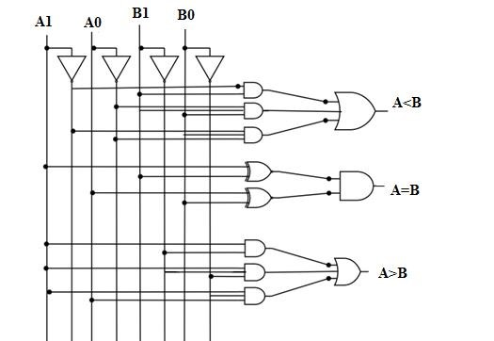

**Four Bit Magnitude Comparator Implementation Details**

**Pin Diagram of IC 7485**

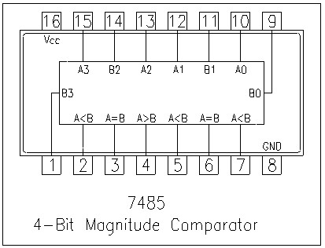

**Logic Diagram of IC 7485**

**Comparing Table**

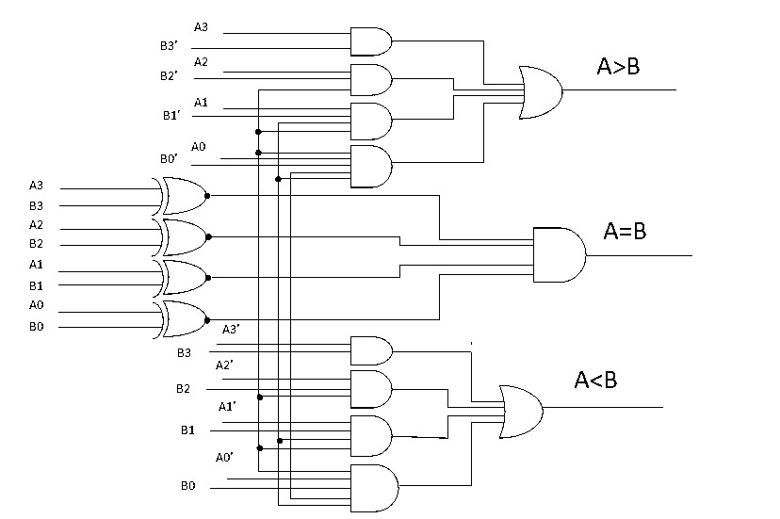

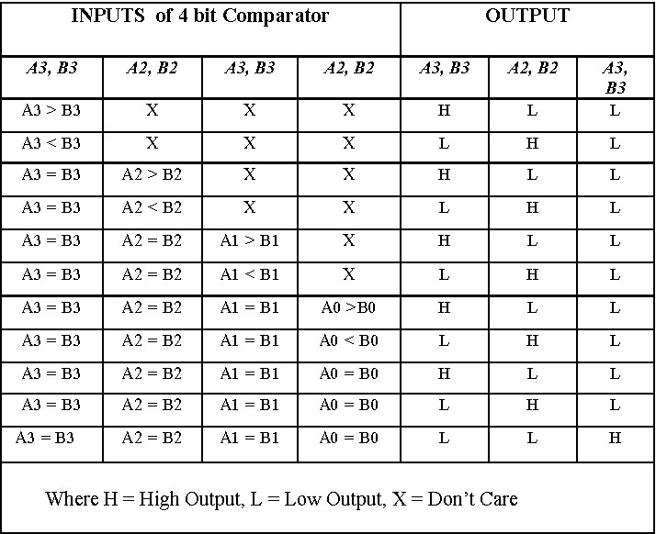

**Lab-Work**:

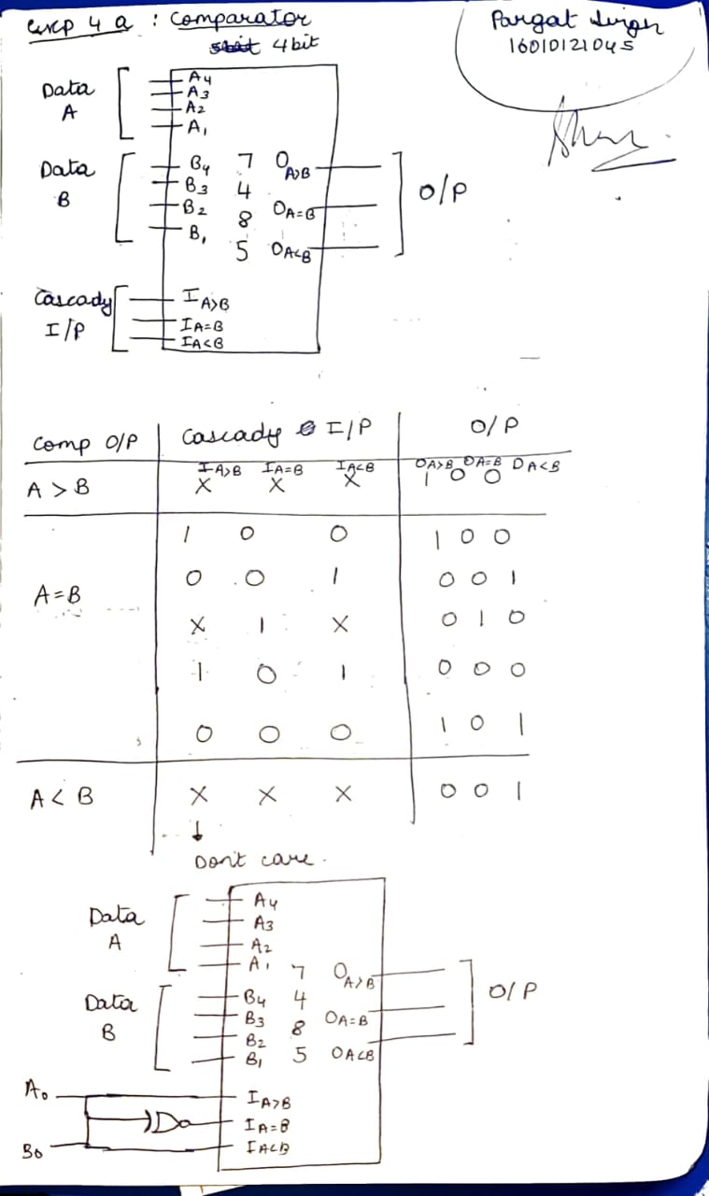

**Conclusion:** Through this experiment we learnt the concept of comparators – 1 bit, 2 bit and 4 bits. We also learnt to implement them through logic diagrams and truth tables.

**Post Lab Descriptive Questions**

1. Design a 1- bit magnitude comparator using logic gates.

|  |  |  |  |  |
| --- | --- | --- | --- | --- |
| **A** | **B** | **f (A>B)** | **f (A=B)** | **f (A<B)** |
| 0 | 0 | 0 | 1 | 0 |
| 1 | 0 | 1 | 0 | 0 |
| 0 | 1 | 0 | 0 | 1 |
| 1 | 1 | 0 | 1 | 0 |

**From the truth table:**

Equation of A > B = A.B’

Equation of A < B = A’.B

Equation of (A = B) = A’.B’ + A.B = A XNOR B = (A.B’ + A’.B)’ = (f(A>B)+f(A<B))’

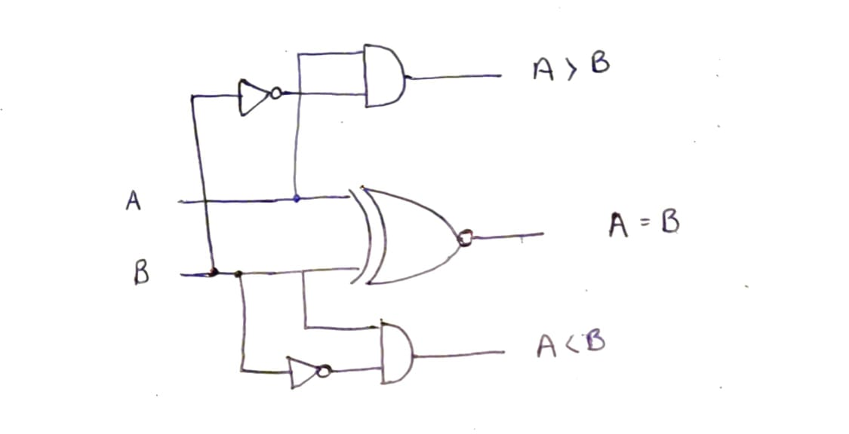

**Experiment / Assignment / Tutorial No. 5**

**Grade: AA / AB / BB / BC / CC / CD /DD**

**Signature of the Staff In-charge with date**

|  |
| --- |
| **Batch: A3 Roll No.: 16010121045 Experiment / assignment / tutorial No.: 5** |

|  |
| --- |
| **Title:** Flip Flops |

**______________________________________________________________________________**

**Objective:**Design of JK Flip flop, D flip flop, T flip flop using NAND Gates & verification of the same flip flop using IC7476

**______________________________________________________________________________**

**Expected Outcome of Experiment:**

**CO2:** Use different minimization technique and solve combinational circuits, synchronous & asynchronous sequential circuits.

**______________________________________________________________________________**

**Books/ Journals/ Websites referred:**

* VLab Link: [http://vlabs.iitkgp.ernet.in/dec/#](http://vlabs.iitkgp.ernet.in/dec/)
* R. P. Jain, “Modern Digital Electronics”, Tata McGraw Hill
* M .Morris Mano, “Digital Logic & computer Design”, PHI
* A.P.Godse, D.A.Godse, “Digital Logic Design”

**Pre Lab/ Prior Concepts:**

Flip-flop is the common name given to two-state devices which offer basic memory for sequential logic operations. Flip-flops are heavily used for digital data storage and transfer and are commonly used in banks called "registers" for the storage of binary numerical data.

**JK-flip flop:** has two inputs, traditionally labeled J and K. IC 7476 is a dual JK master slave flip flop with preset and clear inputs. If J and K are different then the output Q takes the value of J at the next clock edge. If J and K are both low then no change occurs. If J and K are both high at the clock edge, then the output will toggle from one state to the other. It can perform the functions of the set/reset flip-flop and has the advantage that there are no ambiguous states.

**D Flip Flop:** tracks the input, making transitions with match those of the input D. The D stands for "data"; this flip-flop stores the value that is on the data line. It can be thought of as a basic memory cell. D flip-flop can be made from J-K flip-flop by connecting both inputs through a not gate.

**T Flip Flop:** T or "toggle" flip-flop changes its output on each clock edge, giving an output which is half the frequency of the signal to the T input. It is useful for constructing binary counters, frequency dividers, and general binary addition devices. It can be made from a J-K flip-flop by tying both of its inputs high.

**Implementation Details:**

**Procedure**

1. Locate IC 7476 on Digital trainer kit
2. Apply various inputs to J & K pins by means of the output on logic output indicator.
3. Connect a pulsar switch to the clock input.
4. Connect the J&K as D and T flip flop as shown in diagrams and verify the respective truth tables.

**Pin Diagram of IC 7476 JK Master- Slave FF**

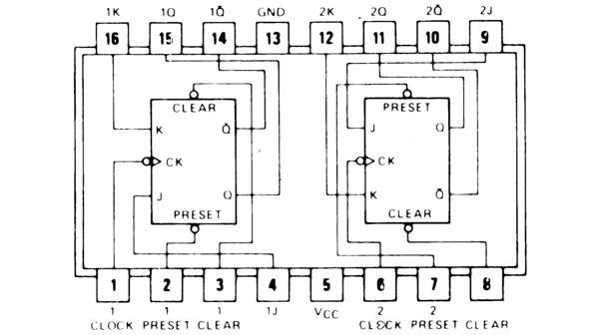

**Logic Symbol Truth Table**

|  |  |  |  |  |  |
| --- | --- | --- | --- | --- | --- |
| **J** | **K** | **Q** | **Q’** | **Qn+1** | **Qn+1’**  **n+1** |
| 0 | 0 | 0 | 1 | 0 | 1 |
| 0 | 0 | 1 | 0 | 1 | 0 |
| 0 | 1 | 0 | 1 | 0 | 1 |
| 0 | 1 | 1 | 0 | 0 | 1 |
| 1 | 0 | 0 | 1 | 1 | 0 |
| 1 | 0 | 1 | 0 | 1 | 0 |
| 1 | 1 | 0 | 1 | 1 | 0 |
| 1 | 1 | 1 | 0 | 0 | 1 |

**JKFF**

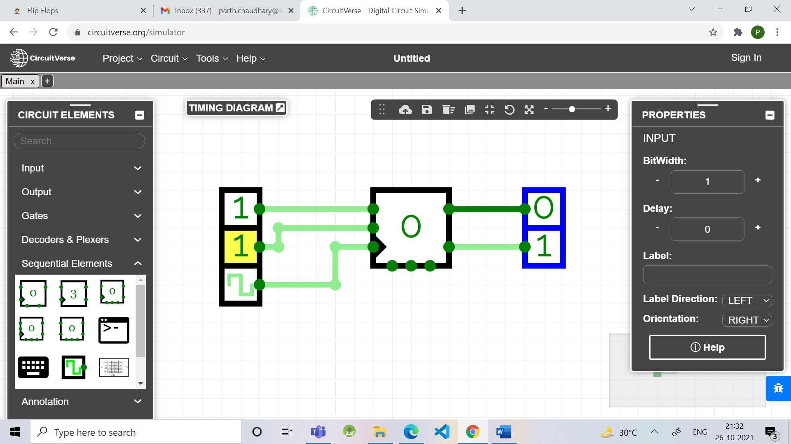

**D FF Truth Table**

|  |  |
| --- | --- |
| **D** | **O/P** |
| 0 | 0 |
| 1 | 1 |

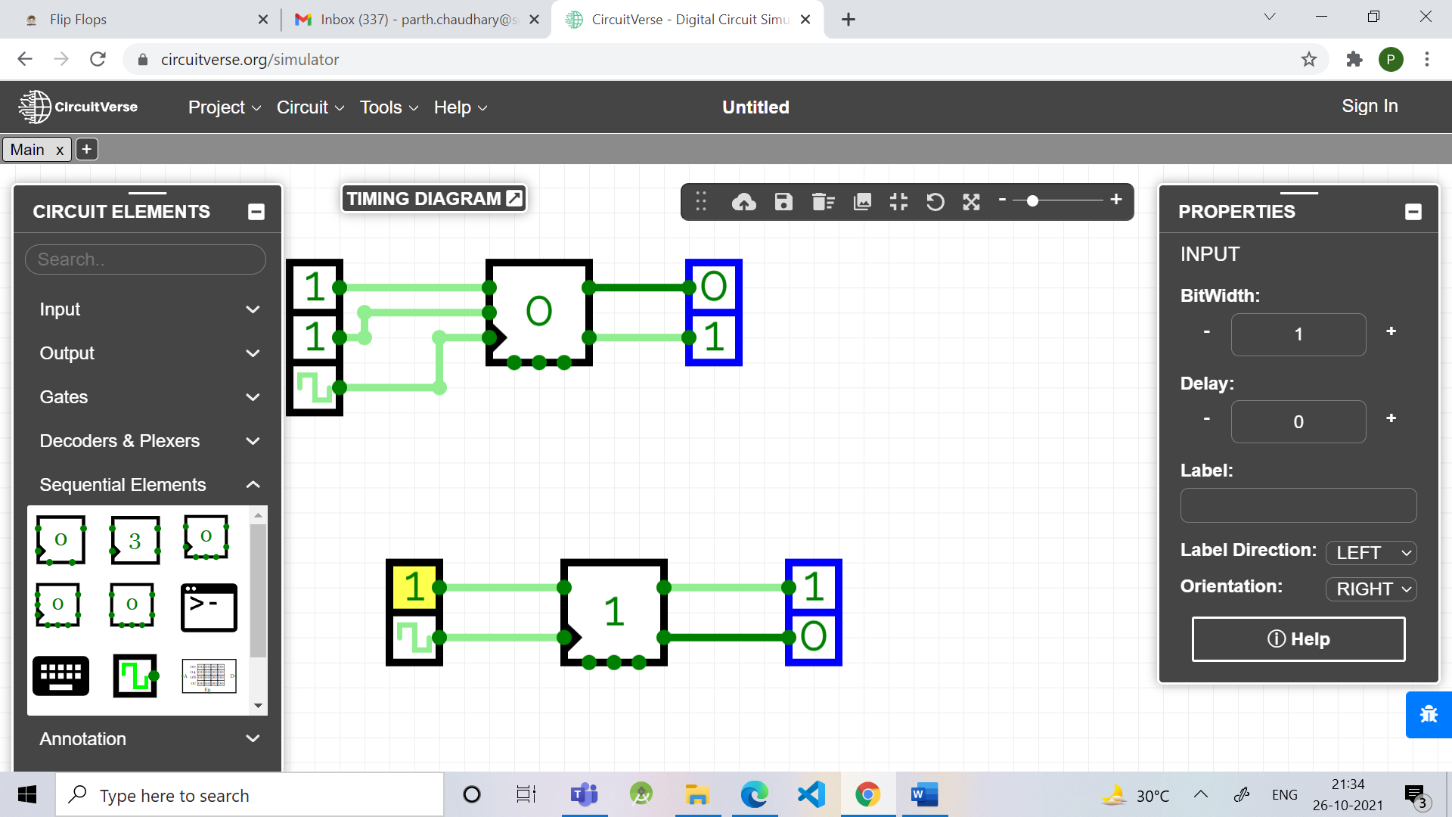

**TFF Truth Table**

|  |  |
| --- | --- |
| **T** | **O/P** |
| 0 | 1 |
| 1 | 0 |

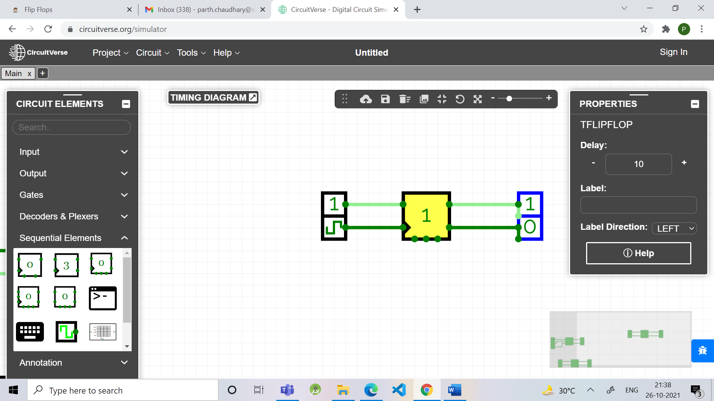

**Diagram of JK Flip Flop using NAND gates**

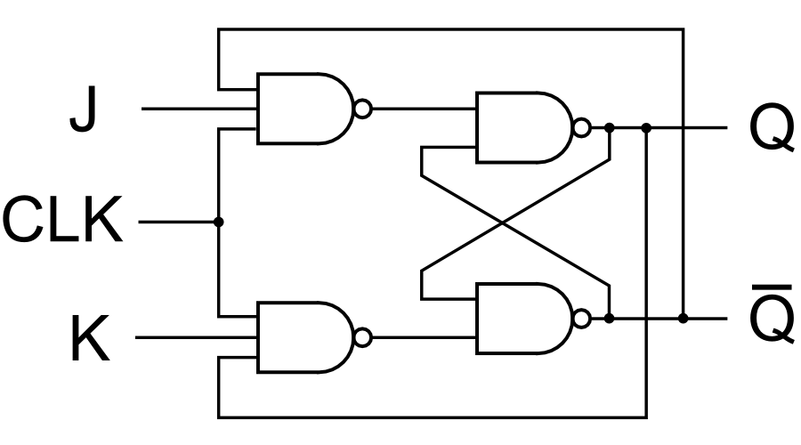

**Lab-Work:**

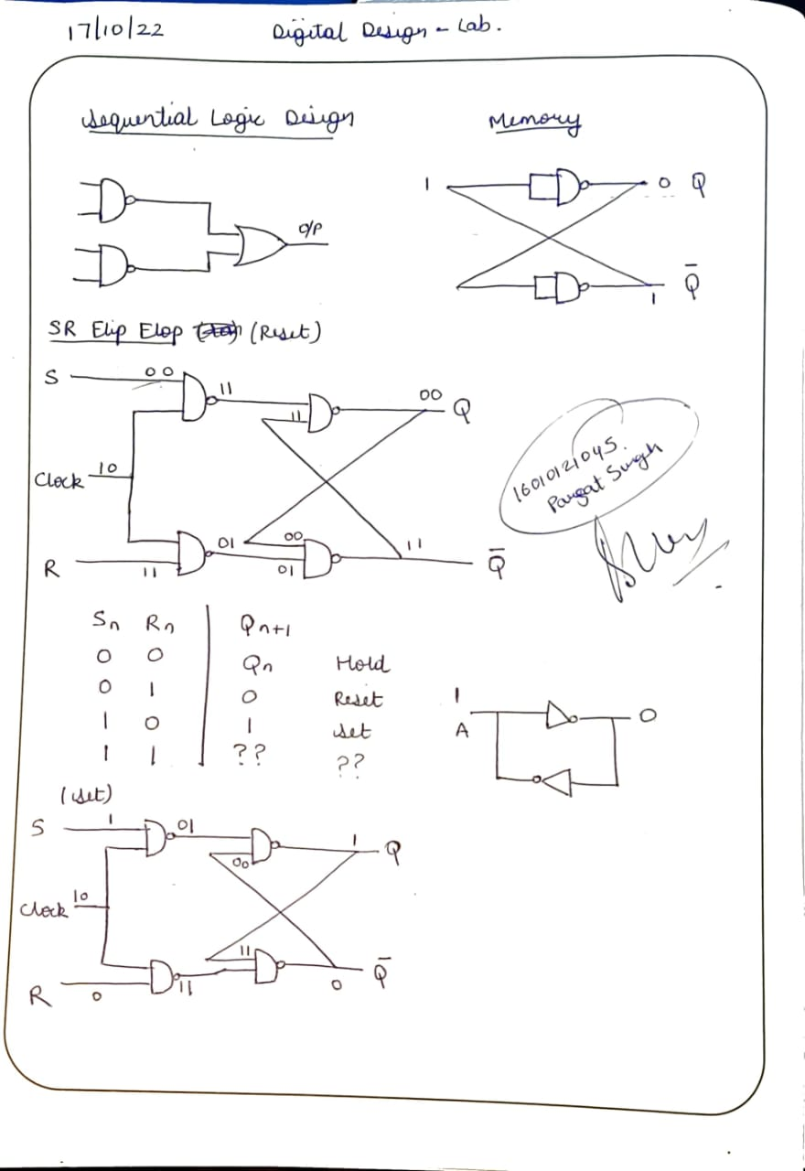

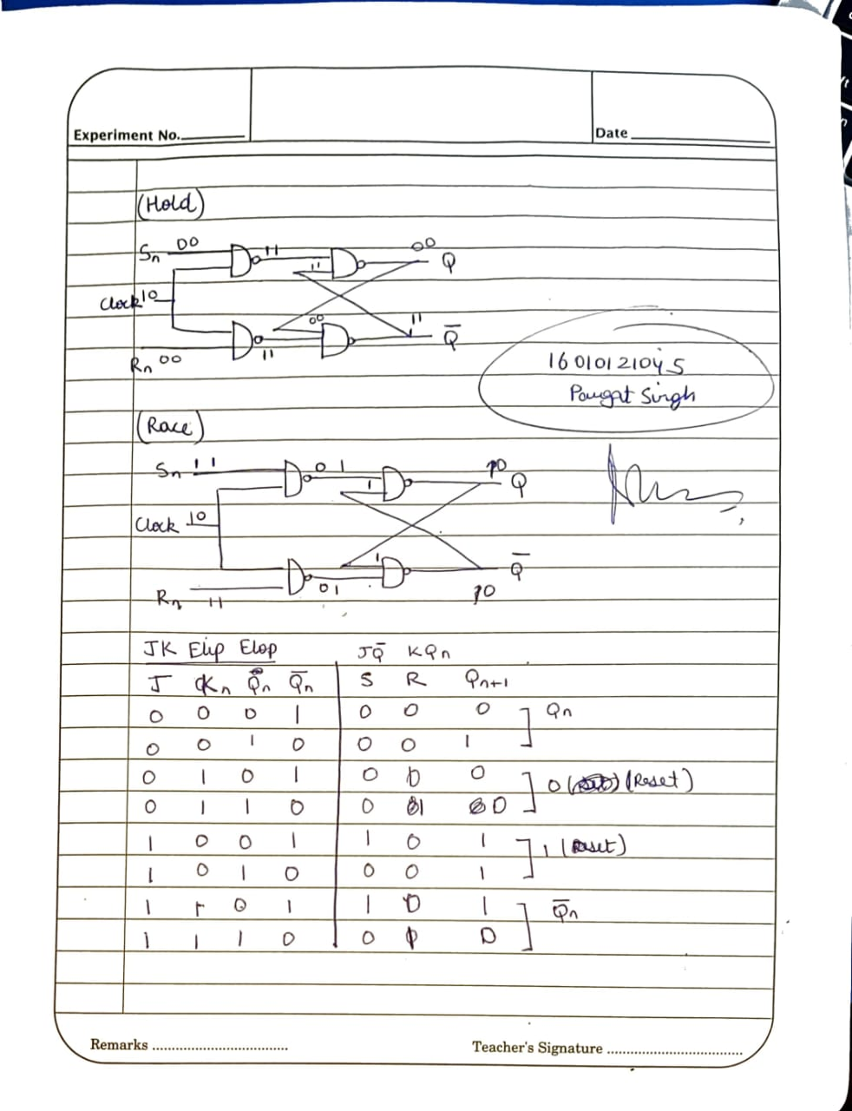

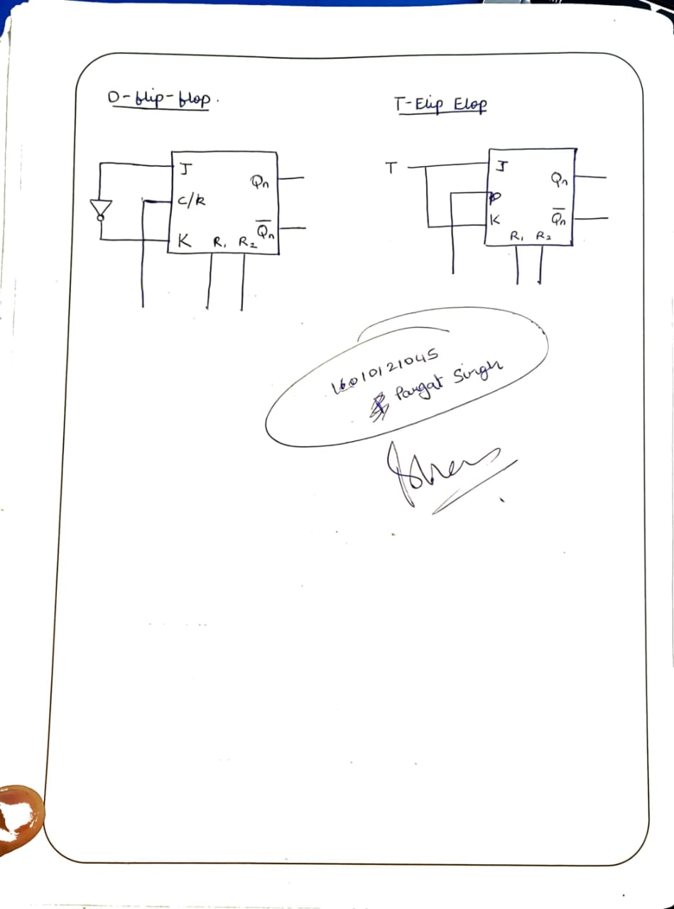

**Conclusion:** In this experiment we learnt about various Flip-Flops and their uses.

We learnt about their Logic Diagrams and how to implement them.We Learnt the design of JK Flip flop, D flip flop, T flip flop using NAND Gates & verification of the same flip flop using IC7476

**Post Lab Descriptive Questions**

1. **How does a JK flip-flop differ from an SR flip-flop in its basic operation?**

* The JK flip-flop is a variation or an improvement of the SR flip-flop. The basic difference between SR & JK flip-flop is that JK flip-flop is edge triggered, while SR flip-flop is level triggered.
* The disadvantage of the SR flip-flop is that both inputs shouldn't be HIGH when the clock is triggered. This is considered an invalid input condition, and the resulting output isn't predictable if this condition occurs.
* The main difference between a JK flip-flop and an SR flip-flop is that in the JK flip-flop, both inputs can be HIGH. When both the J and K inputs are HIGH, the Q output is toggled, which means that the output alternates between HIGH and LOW. Thereby the invalid condition which occurs in the SR flip-flop is eliminated.

1. **What is use of characteristic and excitation table?**

* A characteristic table has the control input (D or T) as the first column, the current state as the middle column, and the next state as the last column. Basically, it tells you how the control bit affects the current state to produce the next state.
* An excitation table has the current state as the first column, the next state as the second column, and the control bit as the third column. Basically, think of this as the state you have (first column), the state you want (second column), and what you must set the control bit (third column) to get the desired state you want. The excitation table is used to implement an FSM

1. **How many flip flops due you require storing the data 1101?**

4 flip-flops are required for storing a data 1101.

1. **Describe the basic difference between pulse-triggered and edge-triggered flip-flops.**

.

* **Triggering:** This means making a circuit active. Making a circuit active means allowing the circuit to take input and give output. Like for example supposed we have a flip-flop. When the circuit is not triggered, even if you give some input data, it will not change the data stored inside the flip-flop nor will it change the output Q or Q'. The triggering is given in form of a clock pulse or gating signal.
* **Pulse Triggering:** In pulse triggering the circuit will become active when the gating or clock pulse is on a particular level. This level is decided by the designer. We can have a negative level triggering in which the circuit is active when the clock signal is low or a positive level triggering in which the circuit is active when the clock signal is high.
* **Edge Triggering:** In edge triggering the circuit becomes active at negative or positive edge of the clock signal. For example if the circuit is positive edge triggered, it will take input at exactly the time in which the clock signal goes from low to high. Similarly input is taken at exactly the time in which the clock signal goes from high to low in negative edge triggering. But keep in mind after the input, it can be processed in all the time till the next input is taken.

**Experiment / Assignment / Tutorial No. 6**

**Grade: AA / AB / BB / BC / CC / CD /DD**

**Signature of the Staff In-charge with date**

|  |
| --- |
| **Batch: A3 Roll No.: 16010121045 Experiment / assignment / tutorial No.: 6** |

|  |
| --- |
| **Title:**  Shift Register |

**______________________________________________________________________________**

**Objective:** To implement the SISO, SIPO, PISO, PIPO shift register using D flips flop

**______________________________________________________________________________**

**Expected Outcome of Experiment:**

**CO2:** Use different minimization technique and solve combinational circuits, synchronous & asynchronous sequential circuits.

**_______________________________________________________________________**

**Books/ Journals/ Websites referred:**

* VLab Link: [http://vlabs.iitkgp.ernet.in/dec/#](http://vlabs.iitkgp.ernet.in/dec/)
* R. P. Jain, “Modern Digital Electronics”, Tata McGraw Hill
* M .Morris Mano, “Digital Logic & computer Design”, PHI
* A.P.Godse, D.A.Godse, “Digital Logic Design”

**Pre Lab/ Prior Concepts:**

A register is capable of shifting its binary information in one or both directions is known as shift register. The logical configuration of shift register consist of a D-Flip flop cascaded with output of one flip flop connected to input of next flip flop. All flip flops receive common clock pulses which causes the shift in the output of the flip flop.The simplest possible shift register is one that uses only flip flop. The output of a given flip flop is connected to the input of next flip flop of the register. Each clock pulse shifts the content of register one bit position to right.

The basic types of shift registers are

* Serial In - Serial Out
* Serial In - Parallel Out
* Parallel In - Serial Out
* Parallel In - Parallel Out
* Bidirectional shift registers.

**Implementation Details:**

**Logic Diagram**

**Serial in Serial Out**

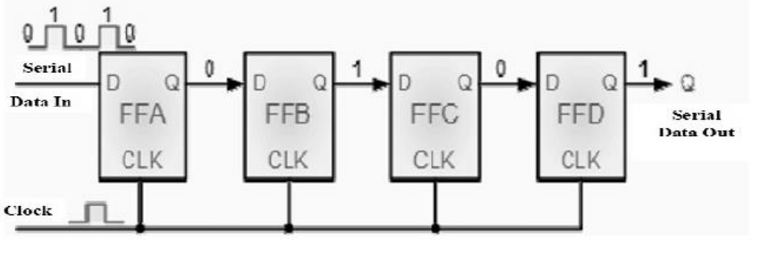

**Truth table**

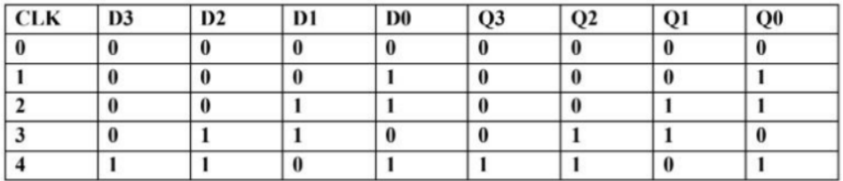

**Serial In - Parallel Out**

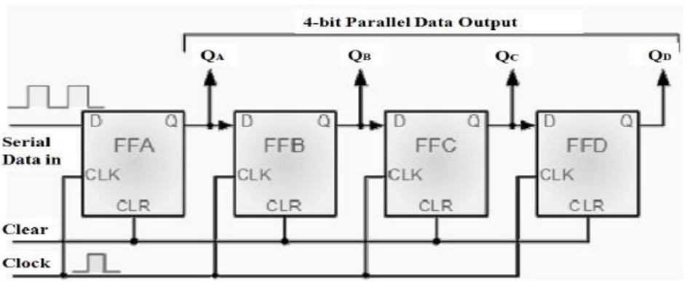

**Truth table**

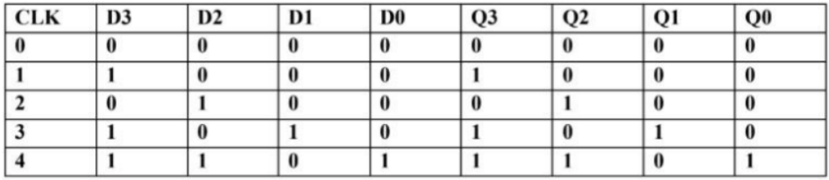

**Parallel In Serial Out**

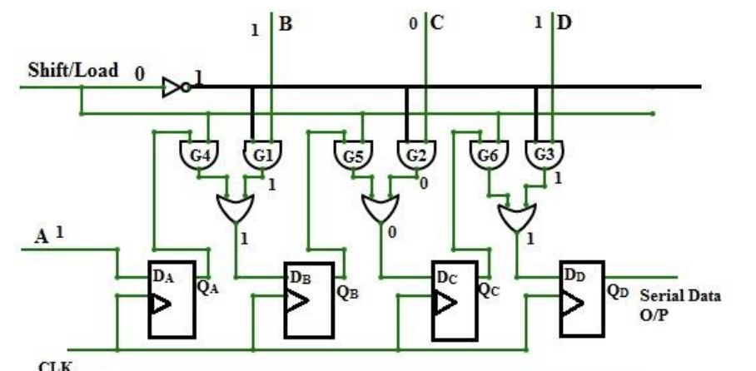

**Truth table**

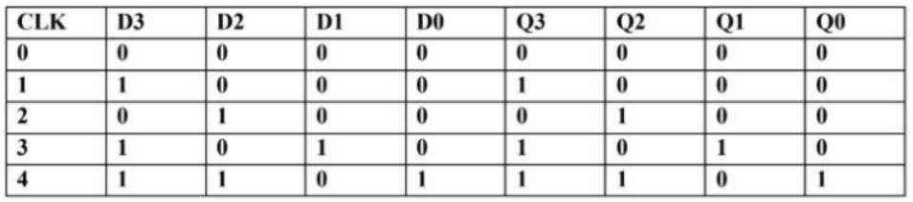

**Parallel In Parallel Out**

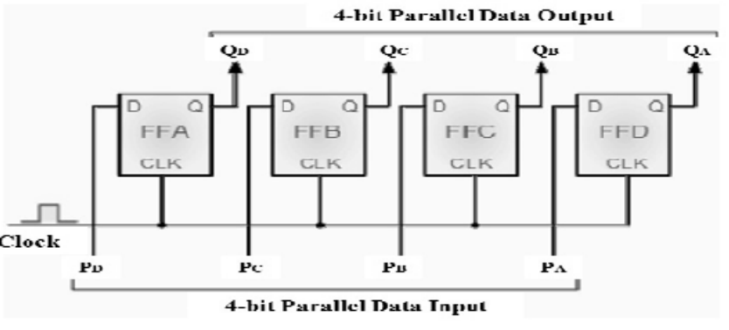

**Truth table**

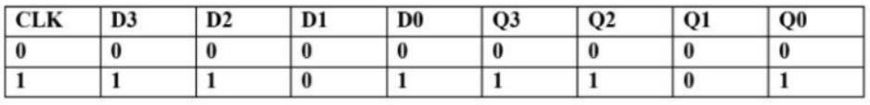

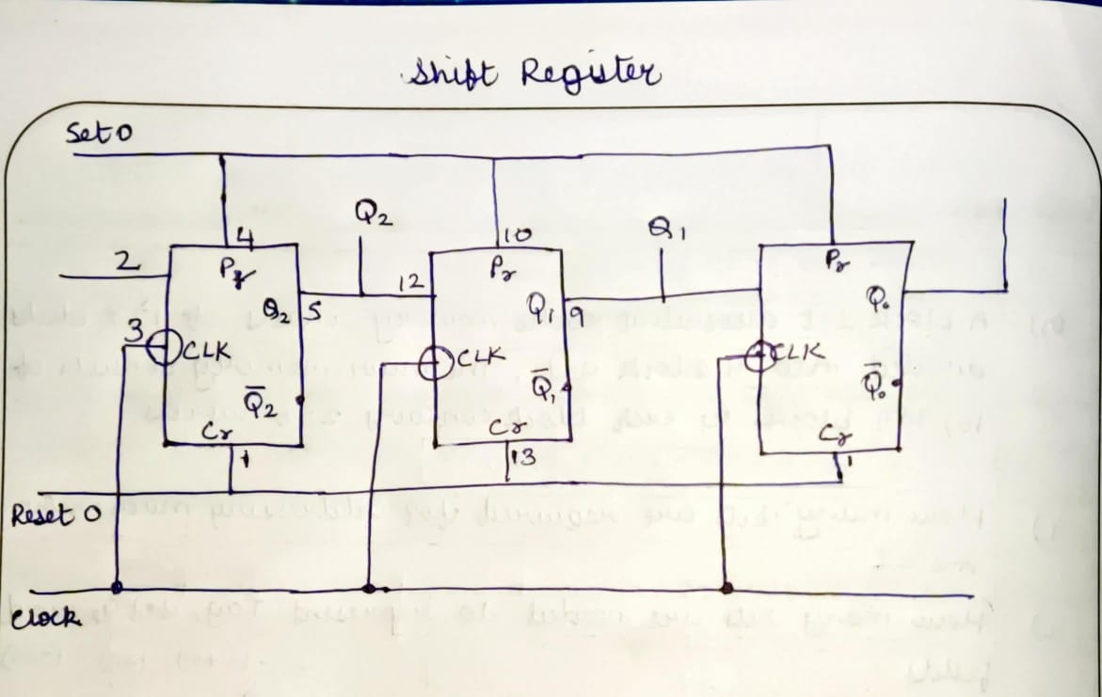

**Conclusion:** Hence, we studied and successfully implemented.

**Post Lab Descriptive Questions**

1. Draw logic diagram for universal shift register using 4:1 MUX.

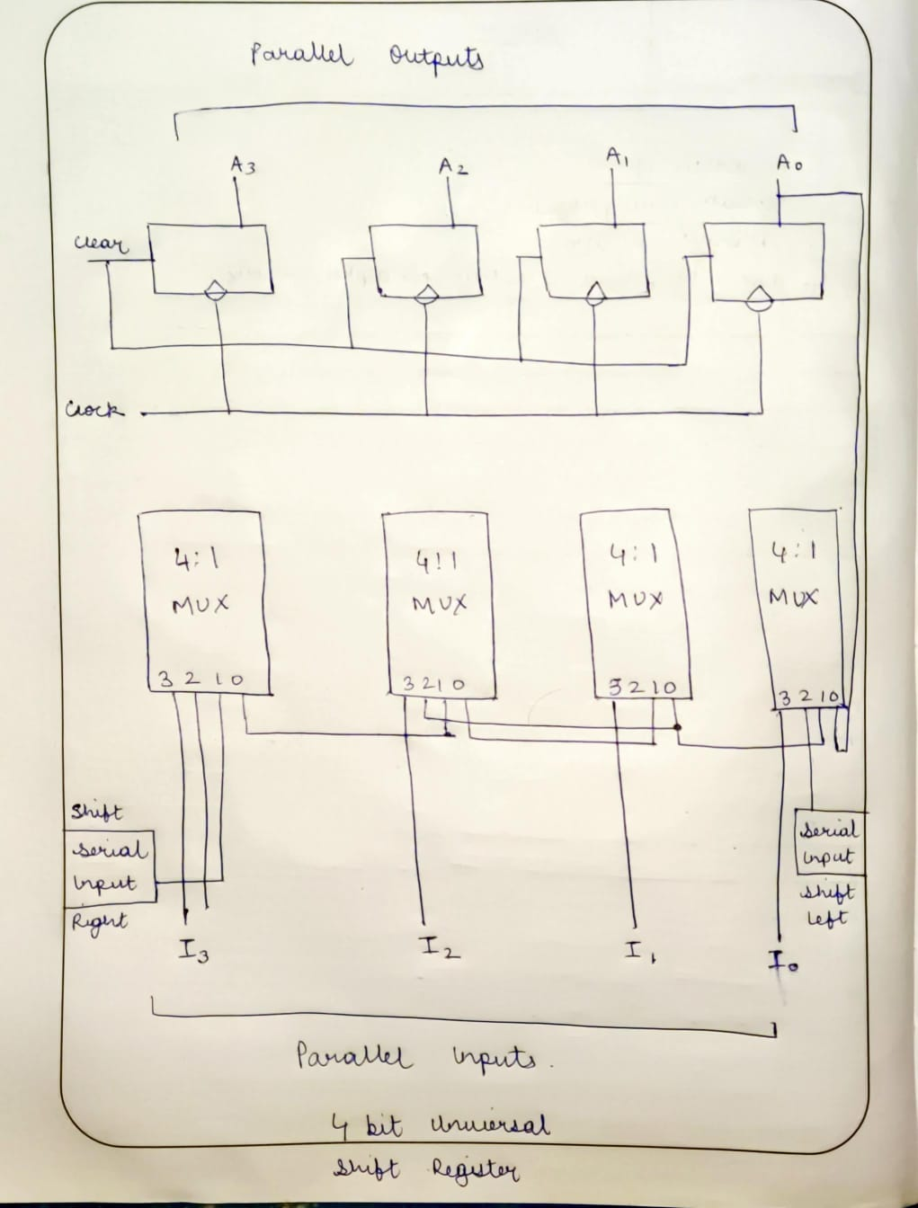

1. Develop the logic diagram for the shift register using JK flip-flop to replace the D flip flop?

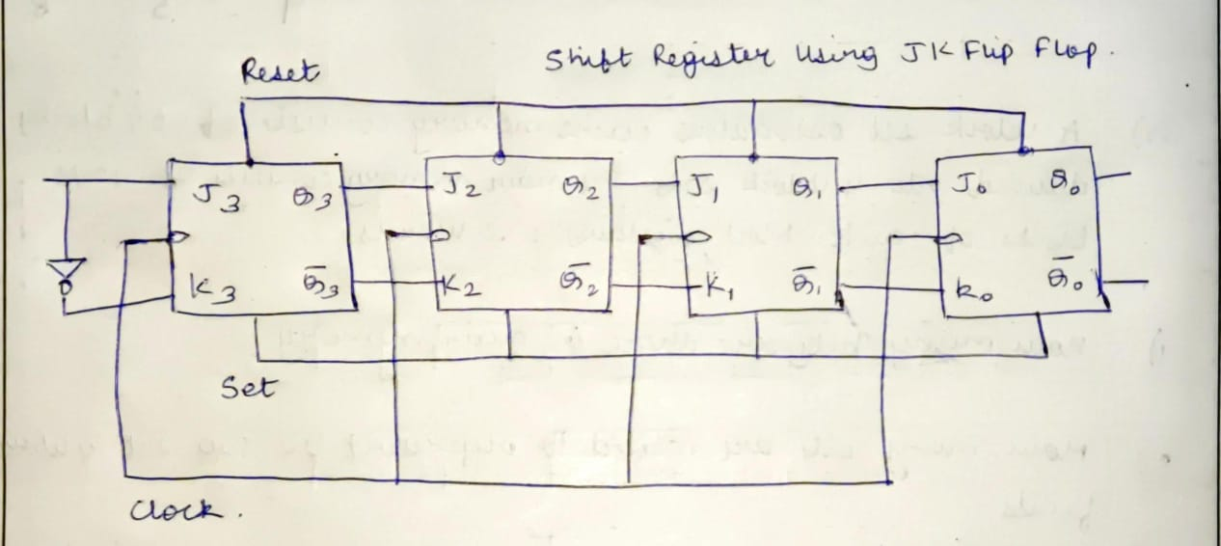

1. How many clock pulses are required to enter a byte of data serially into an 8-bit shift register?

The number of individual data latches required to make up a single Shift Register device is usually determined by the number of bits to be stored with the most common being 8-bits (one byte) wide constructed from eight individual data latches. Shift Registers are used for data storage or for the movement of data and are therefore commonly used inside calculators or computers to store data such as two binary numbers before they are added together, or to convert the data from either a serial to parallel or parallel to serial format. The individual data latches that make up a single shift register are all driven by a common clock (CLK) signal making them synchronous devices.

**Experiment / Assignment / Tutorial No. 7**

**Grade: AA / AB / BB / BC / CC / CD /DD**

**Signature of the Staff In-charge with date**

|  |
| --- |
| **Batch: A3 Roll No.: 1601012104 Experiment / assignment / tutorial No.: 7** |

|  |
| --- |
| **Title:** VHDL programming for gates. |

**______________________________________________________________________________**

**Objective:**

**______________________________________________________________________________**

**Expected Outcome of Experiment:**

**CO4:** Implement digital networks using VHDL.

**______________________________________________________________________________**

**Books/ Journals/ Websites referred:**

* ModelSim Software Link:

https://www.mentor.com/company/higher_ed/modelsim-student-edition

* J. Bhasker, “VHDL Primer”, Pearson Education
* Douglas L. Perry, “VHDL Programming by Example”, Tata McGraw Hill
* http://esd.cs.ucr.edu/labs/tutorial/

**Pre Lab/ Prior Concepts:**

VHDL is an acronym for VHSlC Hardware Description Language (VHSIC is an acronym for Very High Speed Integrated Circuits). It is a hardware description language that can be used to model a digital system at many levels of abstraction ranging from the algorithmic level to the gate level. The complexity of the digital system being modeled could vary from that of a simple gate to a complete digital electronic system, or anything in between. The digital system can also be described hierarchically. Timing can also be explicitly modeled in the same description.

**VHDL Programming Structure**

Entity and Architecture are the two main basic programming structures in VHDL.

**Entity:** Entity can be seen as the black box view of the system. We define the inputs and outputs of the system which we need to interface. It is used to declare the I/O ports of the circuit.

Eg:

Entity ANDGATE is

Port (A: in std_logic;

B: in std_logic;

Y: out std_logic);

End entity ANDGATE;

Entity name ANDGATE is given by the programmer, each entity must have a name.

**Architecture:** Architecture defines what is in our black box that we described using ENTITY. The description code resides within architecture portion. Either behavioral or structural models can be used to describe our system in the architecture. In Architecture we will have interconnections, processes, components, etc.

Eg:

Architecture AND1 of ANDGATE is

--declarations

Begin

--statements

Y <= A AND B;

End architecture AND1;

Entity name or architecture name is user defined. Identifiers can have uppercase alphabets, lowercase alphabets, and numbers and underscore (_). First letter of identifier must be an alphabet and identifier cannot end with an underscore. In VHDL, keywords and user identifiers are case insensitive.

VHDL is strongly typed language i.e. every object must be declared. Standardized design libraries are typically used and are included prior to the entity declaration. This is accomplished by including the code "library ieee;" and "use ieee.std_logic_1164.all;"

**Implementation Details:**

**VHDL program code**

library ieee;  
use ieee.std_logic_unsigned.all;  
use ieee.std_logic_1164.all;  
use ieee.std_logic_arith.all;  
  
entity exp_7 is  
port(  
a,b,c : in std_logic;  
s, carry : out std_logic  
);  
end entity;  
  
architecture exp7_arch of exp_7 is  
begin  
s <= a xor b xor c;  
carry <= (a and b) or (c and a) or (c and b);  
end;

**RTL Viewer Output:**

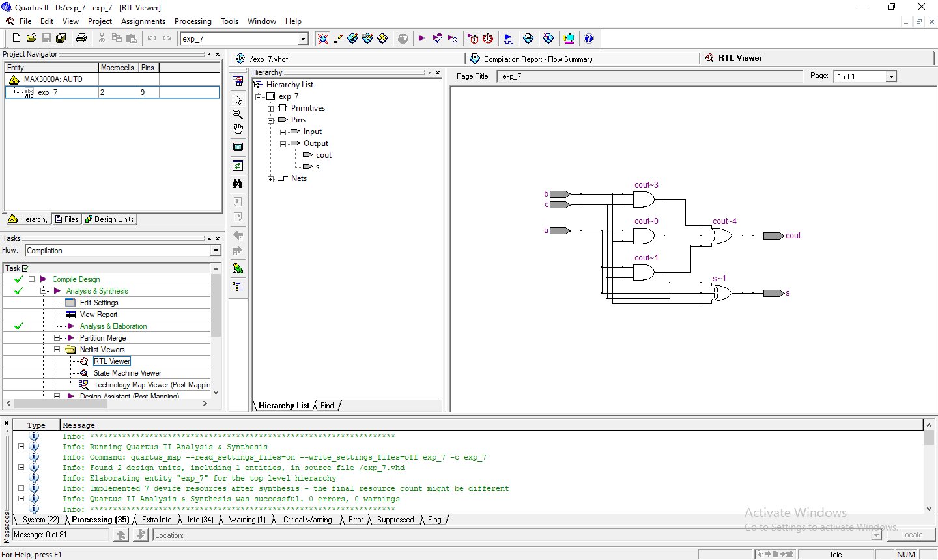

**Full Adder Test Branch**

library IEEE;  
use IEEE.STD_LOGIC_1164.all;  
use IEEE.STD_LOGIC_arith.all;  
use IEEE.STD_LOGIC_unsigned.all;  
  
entity fulladder_gate_test is -- entity of tb should be blank  
end fulladder_gate_test;  
--}} End of automatically maintained section  
architecture fulladder_gate_test_arch of fulladder_gate_test is  
 component fulladder_gate is -- same as entity of your main code  
port(  
a,b,c : in std_logic;  
sum,carry: out std_logic  
);  
 end component;  
   
 signal a,b,c,sum,carry : STD_LOGIC;  
begin  
uut: fulladder_gate port map (a,b,c,sum,carry) ; --positional mapping  
process  
 begin -- write down the test cases  
 a <='0';  
 b<='0';  
 c<='0';  
 wait for 10 ns;  
 a <='0';  
 b<='0';  
 c<='1';  
 wait for 10 ns;  
  a <='0';  
 b<='1';  
 c<='0';  
  wait for 10 ns;  
  a <='0';  
 b<='1';  
 c<='1';  
  wait for 10 ns;  
  a <='1';  
 b<='0';  
 c<='0';  
 wait for 10 ns;  
 a <='1';  
 b<='0';  
 c<='1';  
 wait for 10 ns;  
 a <='1';  
 b<='1';  
 c<='0';  
 wait for 10 ns;  
 a <='1';  
 b<='1';  
 c<='1';  
 wait for 10 ns;  
 end process;  
   
end ;

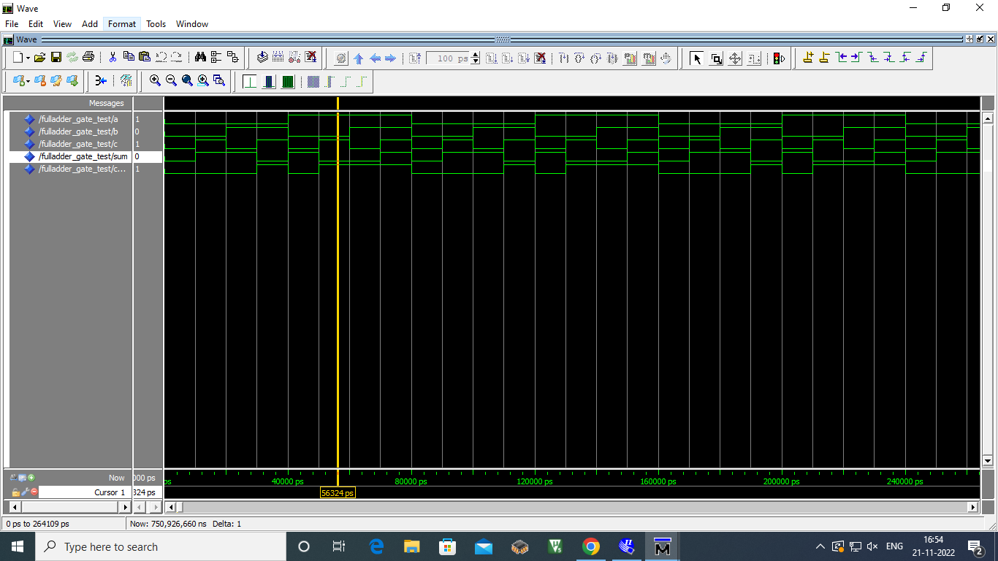

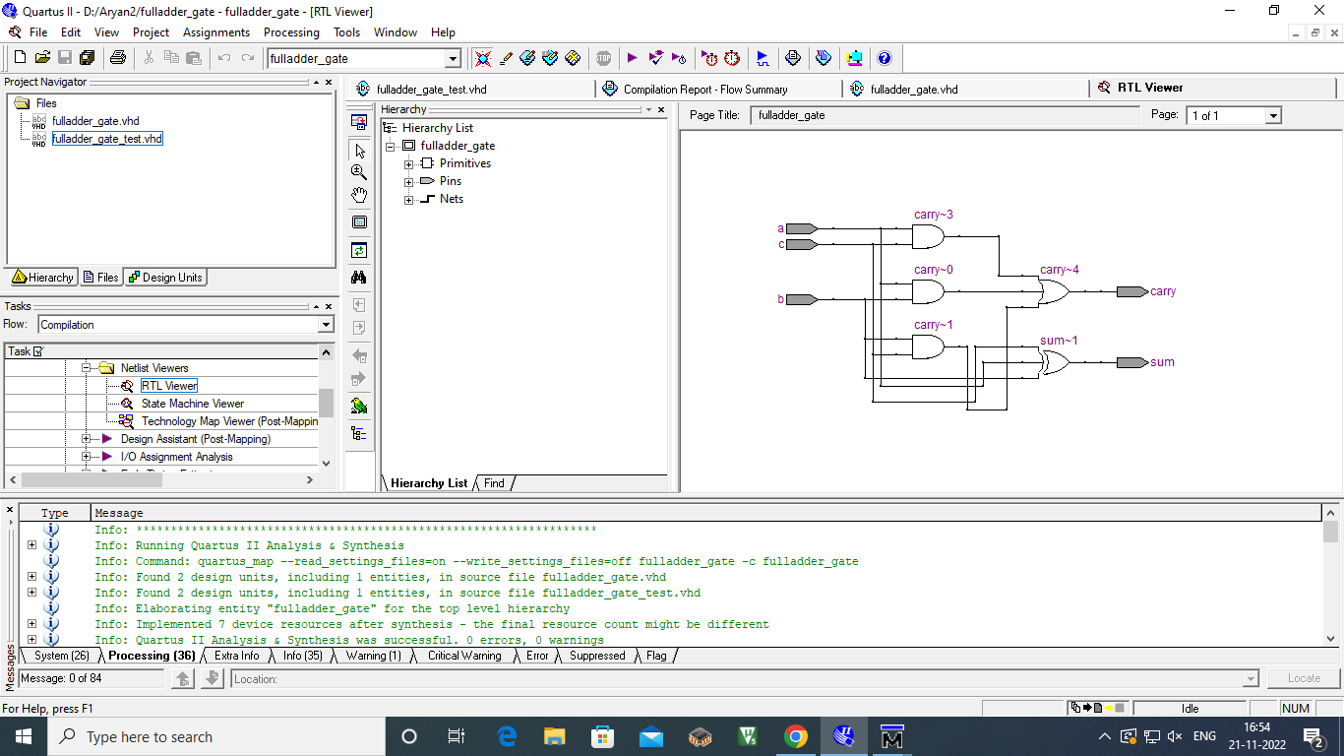

**Conclusion:**

**Successfully implemented the given task.**

**Post Lab Descriptive Questions**

1. What are two types of HDL?

HDLs are standard text-based expressions of the structure of electronic systems and their behaviors over time. Like concurrent programming languages, HDL syntax and semantics include explicit notations for expressing concurrency. However, in contrast to most software programming languages, HDLs also include an explicit notion of time, which is a primary attribute of hardware.

The two most widely used and well-supported HDL varieties used in industry are Verilog and VHDL:

The VHSIC Hardware Description Language (VHDL) is a hardware description language (HDL) that can model the behavior and structure of digital systems at multiple levels of abstraction, ranging from the system level down to that of logic gates, for design entry, documentation, and verification purposes. Verilog, standardized as IEEE 1364, is a hardware description language (HDL) used to model electronic systems. It is most commonly used in the design and verification of digital circuits at the register-transfer level of abstraction. It is also used in the verification of analog circuits and mixed-signal circuits, as well as in the design of genetic circuits.

**Experiment / Assignment / Tutorial No. _______**

**Grade: AA / AB / BB / BC / CC / CD /DD**

**Signature of the Staff In-charge with date**

|  |
| --- |
| **Batch: A3 Roll No.: 16010121045 Experiment / assignment / tutorial No.: 8** |

|  |
| --- |
| **Title:** 4:1 Mux in VHDL |

**______________________________________________________________________________**

**Objective:** Design of 3 bit asynchronous counter using JK flip flop in VHDL

**______________________________________________________________________________**

**Expected Outcome of Experiment:**

**CO2:** Use different minimization technique and solve combinational circuits, synchronous & asynchronous sequential circuits.

**CO4:** Implement digital networks using VHDL

**______________________________________________________________________________**

**Books/ Journals/ Websites referred:**

* VLab Links: <http://vlabs.iitb.ac.in/vlabs-dev/labs/dldesignlab/experimentlist.html>
* R. P. Jain, “Modern Digital Electronics”, Tata McGraw Hill
* M .Morris Mano, “Digital Logic & computer Design”, PHI
* [https://wiki.engr.illinois.edu/download/attachments/84770821/08](https://wiki.engr.illinois.edu/download/attachments/84770821/08-Multiplexers.pdf?version=2&modificationDate=1285128827000)- [Multiplexers.pdf?version=2&modificationDate=128512882700](https://wiki.engr.illinois.edu/download/attachments/84770821/08-Multiplexers.pdf?version=2&modificationDate=1285128827000)0

**Pre Lab/ Prior Concepts:**

**Multiplexer:** Multiplexer is a special type of combinational circuit. It is a digital circuitwhich selects one of the n data inputs and routes it to the output. The selection of one of the n inputs is done by the select lines. To select n inputs we require m select lines, such that 2m=n. Depending on the digital code applied at the select inputs, one out of the n data sources is selected and transmitted to a single output . E is called as the strobe or enable input which is useful for cascading. It is generally on active low terminal that means it will perform the required operation when it is low. The multiplexer act like a digitally controlled single pole, multiple way switches. The output gets connected to only one input at a time. In most of the electronic system the digital data is available on more than one line. It is necessary to route the data over a single line, under such circumstances input at a time

**Types of Multiplexer:**

1. 2:1 Multiplexer
2. 4:1 Multiplexer
3. 8:1 Multiplexer
4. 16:1 Multiplexer
5. 32:1 Multiplexer

**Implementation Details of 4:1 MUX**

library IEEE;

use IEEE.STD_LOGIC_1164.all;

use IEEE.STD_LOGIC_arith.all;  
use IEEE.STD_LOGIC_unsigned.all;

entity vhdlmux_test is -- entity of tb should be blank end vhdlmux_test;  
--}} End of automatically maintained section architecture vdhlmux_test_arch of vhdlmux_test is component vdhlmux is -- same as entity of your main code

port(  
a,b,c,d:in std_logic;  
sel :in std_logic_vector(1 downto 0);

y:out std_logic );

end component;

signal a,b,c,d,y : STD_LOGIC;

signal sel :std_logic_vector(1 downto 0);  
begin  
uut: vdhlmux port map (a,b,c,d,sel,y) ; --positional mapping process

begin -- write down the test cases

a<='0'; b<='0'; c<='1'; d<='1';  
wait for 10ns;

sel <="00"; wait for 10ns;

sel <="01"; wait for 10ns; sel <="10"; wait for 10ns; sel <="11";

wait for 10ns;

end process;

end ;

**Screenshots**

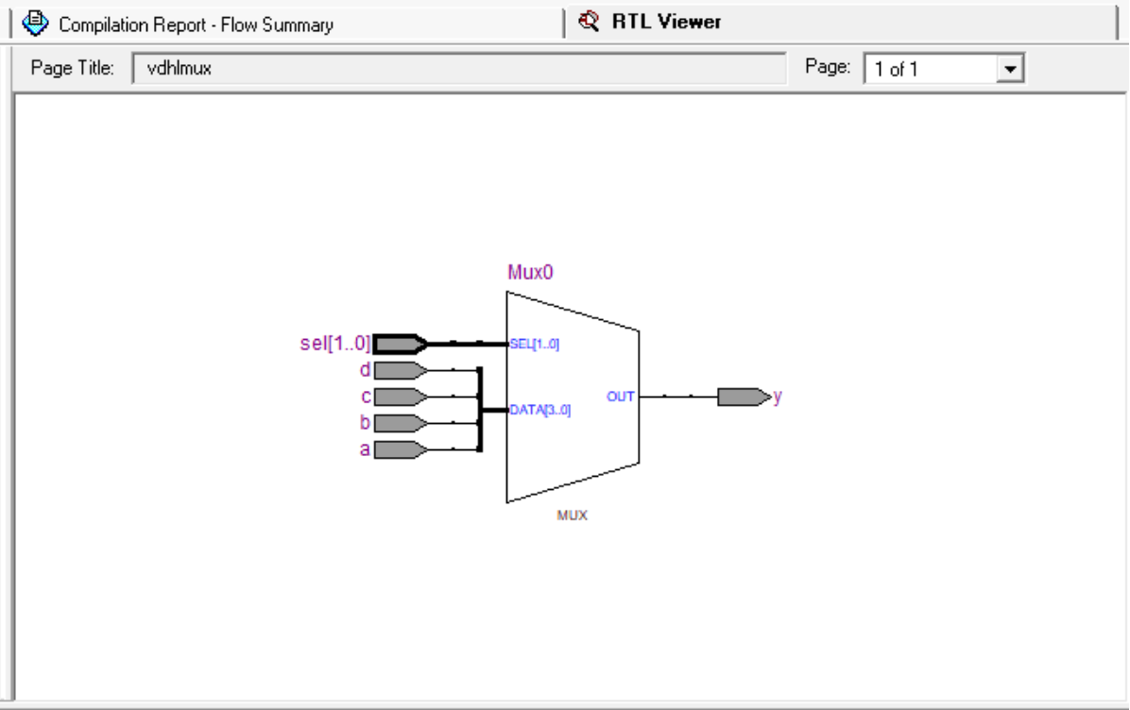

**Conclusion:** Hence**,** we successfully implemented mux in vhdl

**Post Lab Descriptive Questions**

1. Application Mux?
2. Multiplexers are used in various applications wherein multiple-data need to be transmitted by using a single line.  
   **Communication System**A communication system has both a communication network and a transmission system. By using a multiplexer, the efficiency of the communication system can be increased by allowing the transmission of data, such as audio and video data from different channels through single lines or cables.
3. **Computer Memory**
4. Multiplexers are used in computer memory to maintain a huge amount of memory in the computers, and also to reduce the number of copper lines required to connect the memory to other parts of the computer.  
   **Telephone Network**
5. In telephone networks, multiple audio signals are integrated on a single line of transmission with the help of a multiplexer.  
   **Transmission from the Computer System of a Satellite**The multiplexer is used to transmit the data signals from the computer system of a spacecraft or a satellite to the ground system by using a GSM satellite.